Earth systems studies
The Adelaide International Bird Sanctuary is a parcel of land that extends from St Kilda to Port Parham along upper Gulf St Vincent in South Australia. This piece of land represents a pivotal stopover for approximately 27,000 migratory shorebirds. The sanctuary is one of the longest continuous coastal reserves in the state, second only to the Coorong.
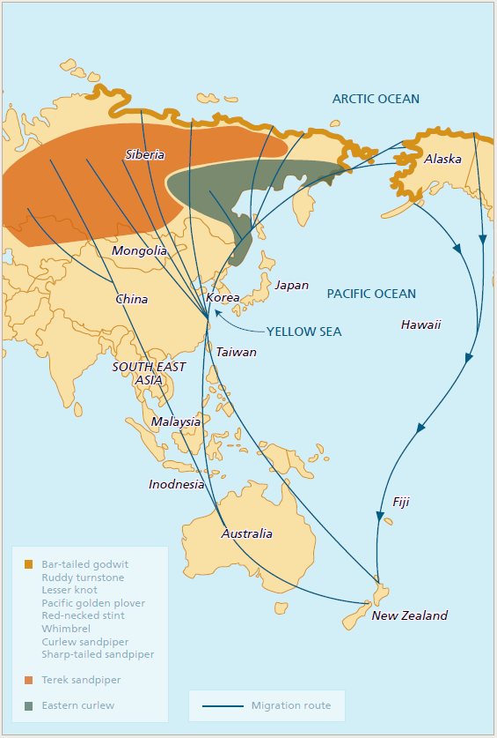
The East Asian Australasian Flyway, a route used by migratory shorebirds that visit the sanctuary
Source: ‘Saltfields – creating the Adelaide International Bird Sanctuary’, Department of Environment, Water and Natural Resources

The Adelaide International Bird Sanctuary (Winaityinaityi Pangkara)
Shorebirds (sometimes called waders) can be found along the shores of beaches, coastlines, estuaries and wetlands.
They congregate in large flocks and feed in shallow waters with their bills in water, mud or sand looking for insects, snails, worms and crabs. These birds are particular in their diet and the habitat in which they hunt for food.
Many of these migratory shorebirds travel from as far away as Siberia and Alaska, passing through up to 22 countries as they travel a migratory route, called the East Asian-Australasian Flyway, to reach the coast of Gulf St Vincent.
This is a distance of over 11,000 kilometres.
From September to March migratory birds visit in large numbers and can be seen in great abundance and diversity across the sanctuary.
Some of these shorebirds, such as the Curlew Sandpiper, Ruddy Turnstone, Red Knot and Great Knot, are listed as threatened species.

Issue #1: loss of habitat
Migratory shorebirds face many threats to their survival. One of which is the loss of habitat from sea level rise, caused through a warming climate.
Shorebirds require low gradient, low energy coastal systems to hunt for food, where they can wade through shallow water along the intertidal zone searching for food.
These birds are not adept swimmers, and can only enter flight whilst standing on land, not floating on water.
Land that joins low gradient, low energy coastlines is often dedicated to industrial purposes.
To prevent flooding of this land, many countries construct sea walls that prevent flooding of land behind the shorebird habitat but flood the coastal zone.
This results in the inundation of low gradient, low energy coastlines and the loss of habitat for migratory shorebirds.
Study area
EES students will study extinction of species (in general), with a subsequent focus on the ruddy turnstone.
They will work collaboratively to collect and collate appropriate field data in the park.
They will report findings of their investigation, (both from the literature and from their own field data), and from the point of view of interactions between the hydrosphere, geosphere and biosphere.

Issue #2: disturbance
Another threat faced by migratory shorebirds is disturbance from dogs, people, vehicles and predators.
Disturbance is when birds are disturbed from feeding and stop feeding to walk or fly away from a real or perceived threat.
The migration from the Arctic Circle to the sanctuary is a huge journey that requires shorebirds to use a lot of energy.
Some species of birds fly non-stop for eight days, not sleeping, eating or drinking whilst in flight.
In order to make this journey, some species of birds will increase their body weight by 70 percent in the form of fat.
This added weight is used by the bird whilst in flight and is critical to the birds’ ability to make the journey across the East Asian Australasian Flyway.
Migratory shorebirds are exhausted once they arrive at the sanctuary.
The presence of threats or perceived threats, such as vehicles, people, dogs and predators requires birds to stop feeding, fly and then monitor the area around them.
This utilises precious energy that will be needed for the migration back to the Arctic Circle.
Study area
Students will study the effects of disturbance on migratory shorebirds within the sanctuary.
This will occur through monitoring of birds at sites at Thompson Beach, Port Gawler and St Kilda.

For more information

Conservation of migratory shorebirds and management plans to help curb the effects of disturbance
National Parks SA Ranger, Tammy Leggett

E: Tammy.Leggett@sa.gov.au

Migratory shorebirds and shorebird migration
NRM Education Officer, Julian Marchant
E: jmarchant@salisbury.sa.gov.au
www.naturalresources.sa.gov.au/
adelaidemtloftyranges

