Earth systems studies
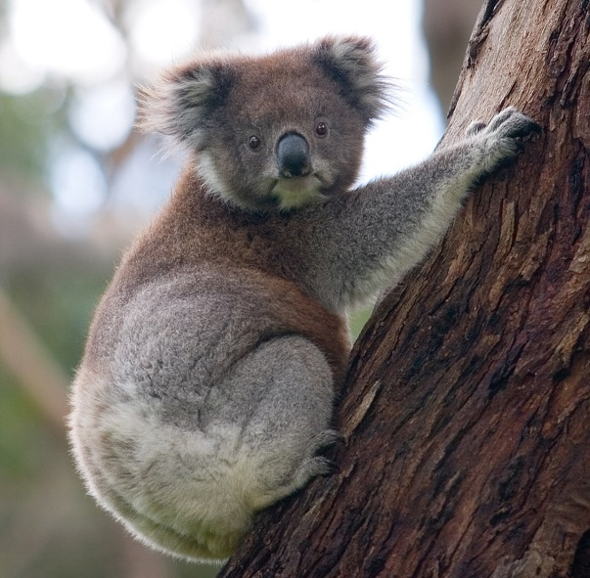
The following are brief overviews of possible senior secondary field-based projects that could be undertaken in South Australian National Parks, as part of the new SACE Earth and Environmental Science course.
Koala (Phascolarctos cinereu), Great Otway National Park. Photo: David Iliff, License: CC-BY-SA 3.0

Anstey Hill Recreation Park
Anstey Hill Recreation Park is situated in the north-eastern suburbs of Adelaide, along the urban fringe of the City of Tea Tree Gully.
The park is a commonly used space for education, entertainment and recreation.
The site is also home to a range of native plant and animal species. Koalas are commonly seen within the park.
The koala is in decline in its natural range. South Australia and the Mount Lofty Ranges represent a haven for an animal that is in decline nationally.
However, koalas are not native to the Mount Lofty Ranges region.
Koalas were introduced to the area and have since prospered.
Koala numbers are increasing throughout Kangaroo Island and the Mount Lofty Ranges. There are management plans in place to curb the population of koalas on Kangaroo Island.
Does more need to be done to curb the koala population within the Mount Lofty Ranges?

Issue #1: Overpopulation
Study area
Students will investigate the habitat within a defined area within the park to determine whether the area is adequately supporting the koala population.
Students will identify species of Eucalyptus that are favoured by koalas and monitor the effects of koala grazing on the health of trees across a defined space in the park.
Students will devise scientifically sound methods of recording data to record the number of koalas seen throughout the park.
Study questions
- What does a healthy tree look like?
- How does this compare to a tree that is under severe grazing pressure?
- What are the effects of overpopulation of a particular animal species on an ecosystem?

Issue #2: Habitat
Study area
Investigate the Mount Lofty Ranges at a landscape scale, recording data on habitat connectivity, food supply and urbanisation to determine the habitat value of the area for a chosen Australian animal species.
Study questions
- Why have koalas thrived throughout the Mount Lofty Ranges but are in decline in other parts of Australia?
- What attributes exist in the landscape of the Mount Lofty Ranges that do not exist in areas where koala populations are reducing?
- Why have certain native species population numbers grown whilst others have declined within the Mount Lofty Ranges?

For more information

Effects of invasive species on natural landscapes and management plans to help curb the effects of invasive species

National Parks SA Ranger, Aislinn McAleer

E: Aislinn.McAleer@sa.gov.au

Connecting National Parks successes and issues to the SACE Earth and Environmental Science subject
NRM Education Officer, Julian Marchant
E: jmarchant@salisbury.sa.gov.au
www.naturalresources.sa.gov.au/
adelaidemtloftyranges

