Earth systems studies
The following are brief overviews of possible senior secondary field-based projects that could be undertaken in South Australian National Parks, as part of the new SACE Earth and Environmental Science course.

Cobbler Creek Recreation Park
Cobbler Creek Recreation Park is sandwiched between Golden Grove and Salisbury in Adelaide’s northern metropolitan suburbs.
Cobbler Creek represents one of the largest undeveloped tracks of land in metropolitan Adelaide and is home to a variety of plant and animal species.
The park contains the largest remaining stand of Mallee Box (Eucalyptus porosa) grassy woodland along the Adelaide Plains.
Only three percent of remnant vegetation exists along the Adelaide plains and Cobbler Creek Recreation Park is recognised as an area of important remnant vegetation and a place that offers a number of recreational activities for park visitors.
Historically, Cobbler Creek was used as a sheep grazing property. The effects of this can still be seen today.

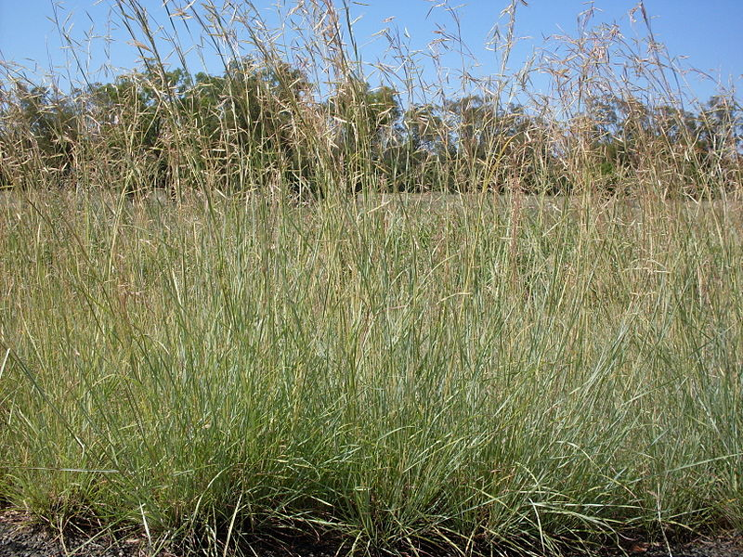
Coolatai Grass (Hyparrhenia hirta)
Source: Wiki Commons, photo: John Tann
Issue #1: pest plant
One of the greatest challenges facing the park is the invasion of Coolatai grass.
Coolatai Grass is an introduced species that displaces native vegetation, smothers native ground cover and burns faster and hotter than many native species.
Hence, the presence of Coolatai grass is considered a fire risk.
Coolatai grass is a highly invasive weed.
Study area
Students will study the effect of an introduced species on an ecosystem, in particular the changes that introduced species make to the functions of an ecosystem.
Students will research areas of remnant bushland and compare this to that of Cobbler Creek Recreation Park. Students will ensure that links between the hydrosphere, geosphere and biosphere are recognised.

Issue #2: water
The quality and quantity of water across the world is essential for people and flora and fauna.

For more information

Effects of invasive species on natural landscapes and management plans to help curb the effects of invasive species

National Parks SA Ranger, Aislinn McAleer

E: Aislinn.McAleer@sa.gov.au

City of Salisbury’s aquifer storage and recharge scheme
NRM Education Officer, Julian Marchant
E: jmarchant@salisbury.sa.gov.au
www.naturalresources.sa.gov.au/
adelaidemtloftyranges
Plants through transpiration and shading, cool the air and ground around them.
Vital to the Cobbler Creek ecosystem is access to water.
With a warming climate, the benefit of using plants to cool the neighbourhoods where humans live is critical.
At the same time, there are more and more pressures on water to be used for purposes other than watering plants.
Cobbler Creek is part of a network of wetlands and retention ponds within the City of Salisbury that alter the movement of water from the hills to the sea by storing stormwater in dams, wetlands, creeks and rivers.
Through this process, water is filtered, injected into underground aquifers and used at a later stage. This process is known as aquifer storage and recharge.
Study area
EES students will study the quality of water from the Cobbler Creek dam to Greenfields Wetlands prior to the water being injected into the aquifer.
The investigation will include recording changes in stormwater quality over time and in different locations.
Study questions
- What roles do plants play in cleaning stormwater?
- How do plants clean stormwater?
- What are some of the benefits of engineering wetlands and riparian zones to collect and store stormwater?

