# Information for Teachers

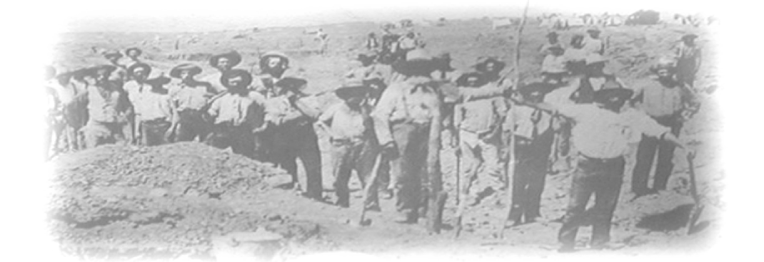

Two of the goldfields in the Echunga area are the Chapel Hill Diggings and the Jupiter Creek Gold Diggings.

## Chapel Hill Diggings

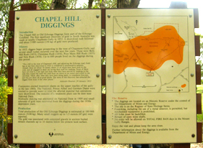A dam provides a water supply at Chapel Hill Diggings, so that gold panning processes can be demonstrated and tried out. Remains of campsites in this area contain small metal artefacts that are useful for demonstrating use of a metal detector, even if no gold is found.

Little remains of the old workings in this area, and there is no student worksheet.

On page 2 there is a map showing the location of Chapel Hill Diggings. Drive along Diggings Road until you see the sign shown in the adjacent photograph. It is about 10m back from the left hand side of the road, just behind a small car park. From the car park, walk down the track by the fence for about 10 minutes. You will find the dam just off the left of the track, and the old campsite is to the right of the track.

## Jupiter Creek Gold Diggings

The remains of Jupiter Creek Gold Diggings are located in a Forest Reserve. A marked trail leads through the diggings. Just follow the red arrows. Along the trail, interpretive signs provide information about the mining techniques used.

A map showing the location of the diggings is on page 3 of this document. The actual route to the goldfields from the Echunga Road is very clearly indicated by a series of brown road signs.

A student worksheet is available for these the diggings.

A brochure, entitled **Gold at Jupiter Creek. A guide to the historic gold diggings** describes the history of the diggings and many of the features of interest to be seen on the walk. Greg Drew prepared the document on behalf of the Department of Mines and Energy.

Copies of this brochure may be purchased for $2.00 each from the following website:

<http://outernode.pir.sa.gov.au/minerals/publications_and_information/brochure>

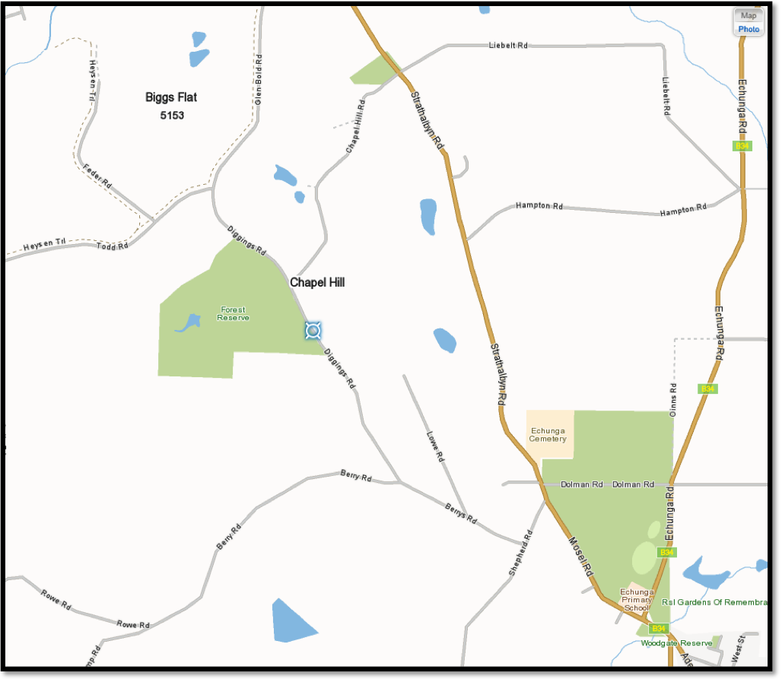

Location of Chapel Hill Diggings

### Relevance of Excursion to the National Curriculum for Year 8

One of the elaborations of the Science Understanding/Earth and space sciences section of the year 8 curriculum states:

Location of Jupiter Creek Gold Diggings

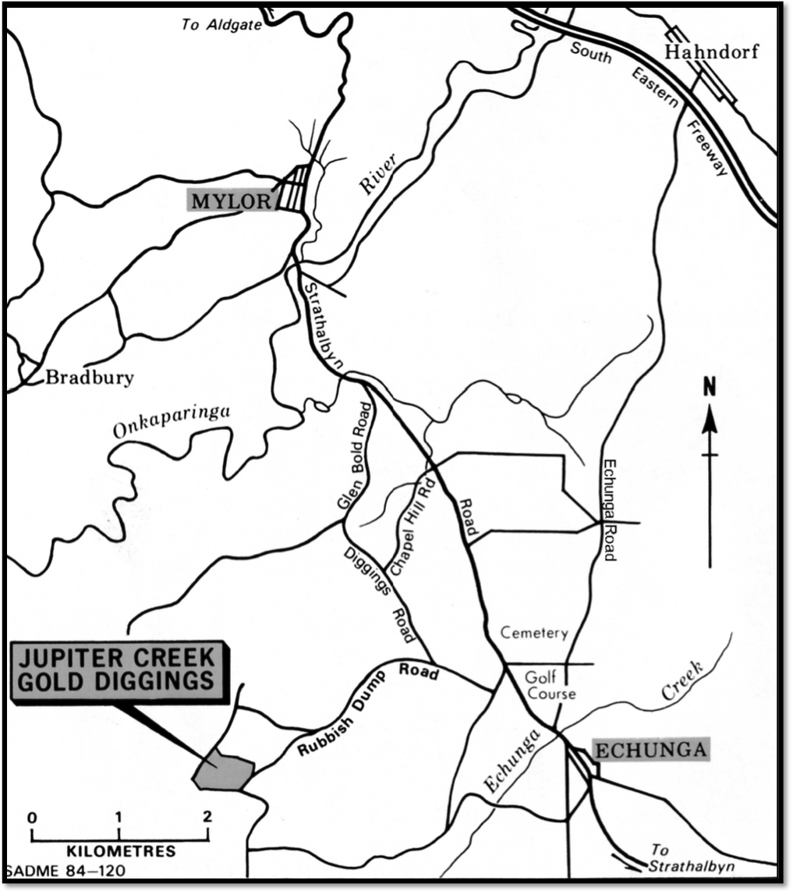

**‘Recognising that some rocks and minerals, such as ores, provide valuable resources.’**

On this excursion students will investigate situations in which a valuable resource may be found; as well as dependence of extraction processes on the properties of the resource.

This excursion also provides a historical insight into an aspect of South Australian life in the nineteenth and early twentieth centuries.

### Why the Location is Geologically and Historically Significant

The Jupiter Creek diggings provide evidence of three situations in which gold may be found, and the variety of extraction processes needed in the different situations.

They also contain examples of and information about former mining technology.

The Chapel Hill Diggings contain a source of water that can be used to demonstrate and apply gold panning procedures.

### Key Concepts to be covered before the excursion

**Many of these key concepts are covered in the brochures that have been provided for you.**

Gold is frequently found in quartz reefs, but weathering and erosion processes transport it to low-lying areas, such as streams. Later sediments may bury streambeds containing gold, so that the gold must be extracted from underground former streams.

A variety of techniques are required to extract gold from these different locations.

Students could be asked to research some of the different locations in which gold may be found, and relations between properties of gold and techniques used to extract.

They could also research the history of the Echunga Goldfields, particularly Jupiter Creek.

## Planning the Excursion

**Everyone who wishes to enter the New Pheonix adit will need a torch and a hard hat. Hard hats can be borrowed from Len Altman at Marden Senior College (phone 8366 2888).**

Allow at least half a day to visit both Chapel Hill and Jupiter Creek diggings, including activities such as gold panning and use of a metal detector..

Visit the sites, with this **Teacher Information Sheet** and the **Answers to Student Worksheet** documents prior to the excursion. Be prepared to discuss with the students the features described in the worksheet, and any other features of geological or historical interest seen on the excursion

The nearest toilets are in Echunga.

Students will need to bring their own food and water, because the nearest shops are in Echunga.

Print the worksheets single-sided and staple them with two staples down the side to make a booklet. This gives students extra space next to each page to include any information or diagrams that they cannot fit into the spaces provided with the questions.

Emphasise the importance of the **Rules for Students**,which areincluded in the worksheets.

Hand the worksheets out in the classroom when you are discussing the excursion with the students and emphasise their importance. Collect them at the end of the lesson and hand them out again at the beginning of the excursion.

## Safety and Ethical Considerations

Carry a small first aid kit with you on the excursion.

If the students use geological hammers to look for quartz crystals, they must wear safety goggles.

Make sure the students do not leave any litter.

Keep the students away from any unfenced mine shafts

Everyone must keep to the defined walking trails.

## Safety Rules (also included in the student worksheet)

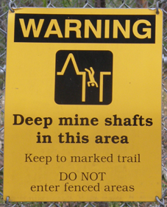Wear a hat and sturdy shoes and apply sunscreen even during winter months.

Carry drinking water.

Carry sufficient food.

Weather conditions can change quickly. Ensure that you wear and bring appropriate clothing.

Keep to the paths

Stay with the group, or you may get lost.

Note that there are no toilets at the site.

Above all, heed the warning on this photograph