Innes National Park
The Innes National Park is on the southwest tip of Yorke Peninsula, about 300 km west of Adelaide.
Plants: The park is rich in coastal plant diversity with 333 native plant species recorded. It retains a high proportion of native vegetation that includes 55 plant species that are endangered, vulnerable or rare for South Australia. Of these, 10 species are co-listed by the national Environment Protection and Biodiversity Conservation Act 1999. There may be opportunity to develop student field studies related to one or more of these endangered, vulnerable or rare native plants.
Animals: The park is habitat for a number of endangered animals including the hooded plover: Increased coastal development and beach usage around Australia has driven the hooded plover to extinction in Queensland and northern NSW, reducing its survival to a few remote beaches in southern Australia, including in the Innes National Park.
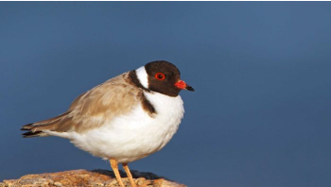
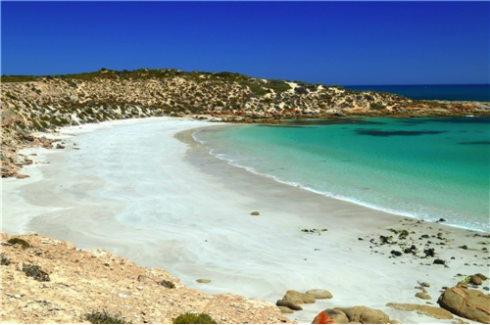

Rising sea levels are thought to be a significant threat to the survival of the hooded plover. It is thought that nesting sites are being lost. There is therefore a need to collect appropriate field data to verify that this is occurring, and to understand the impact that rising sea level will have. EES students will study extinction of species (in general), with a subsequent focus on the hooded plover. They will work collaboratively to collect and collate appropriate field data in the Park. They will report findings of their investigation, (both from the literature and from their own field data), and from the point of view of interactions between the hydrosphere, geosphere and biosphere.
The Department of Environment and Water (DEW) Landscapes Ranger, Jasmine Swales, can present an excellent talk to your students, on site. Specific requirements and details can be negotiated directly with Jasmine: Jasmine.Swales@sa.gov.au
Accommodation is available in the Stenhouse Bay hall, near the entrance to the park. The cost of this accommodation is $350 /night (less 20% for educational purposes), including entry.
The cost of entry (only) to the park is $10 vehicle entry/day.
DEW presentations to your class are free of charge (conditions apply)

