# **Student Worksheet**

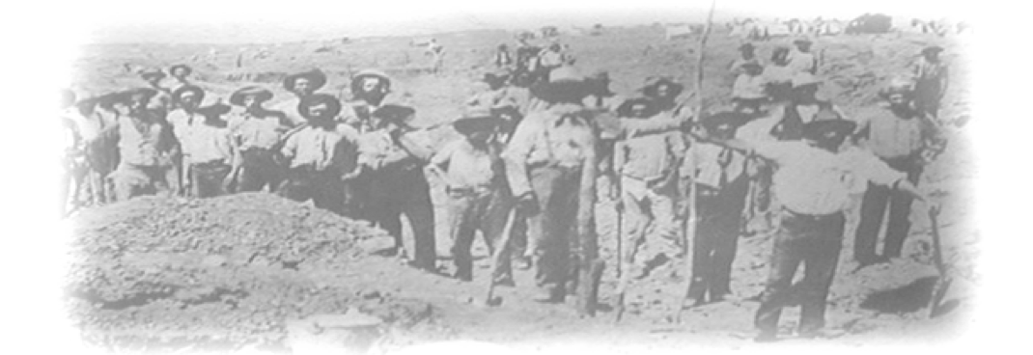

## **Name ___________________ Date __________**

## **Safety Rules**

**Wear a hat and sturdy shoes and apply sunscreen even during winter months.**

**Carry drinking water**

**Carry sufficient food.**

**Weather conditions can change quickly. Ensure that you wear and bring appropriate clothing.**

**Keep to the paths**

**Stay with the group, or you may get lost.**

**Note that there are no toilets at the site.**

**Above all, heed the warning on this photograph!**

## **Introduction to the Goldfields Excursion**

On this excursion, you will walk along a heritage trail that provides evidence of a variety of mining operations that were used in the nineteenth and early twentieth centuries.

Gold was discovered at Jupiter Creek in 1868. Within months there were 1500 people on the field. A town of tents, galvanised iron structures and wattle and daub houses sprang up alongside more substantial buildings, such as a hotel and several stores. Today nothing remains of homes or shops.

None of the South Australian goldfields were very successful, but, at the end of the nineteenth century, the Echunga goldfields had become South Australia’s major producer of gold. The Jupiter Creek diggings probably produced between 20, 000 and 50, 000 ounces of gold.

## **Mining Techniques**

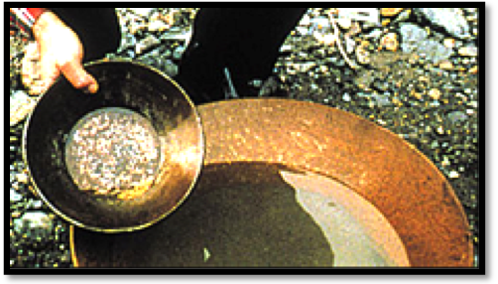

Panning for Alluvial Gold

At Jupiter Creek, as at many goldfields, gold is found in three situations.

Alluvial Gold

This is usually the first gold to be discovered and the first to be worked out. It is the gold found in the soil, and in creeks and rivers. It can be extracted by panning and miners usually worked on their own.

Once the alluvial gold is exhausted, the miners need to find out where it originally came from, and how it was transported**.**

Gold in Ancient Stream Beds

Sometimes streams carrying alluvial gold become buried by sediment over millions of years, so miners dig shafts to gain access to this gold. The diagram below shows how small groups of miners extracted the gold-bearing alluvium; and the photograph shows the top of one of the many shafts in the goldfields.

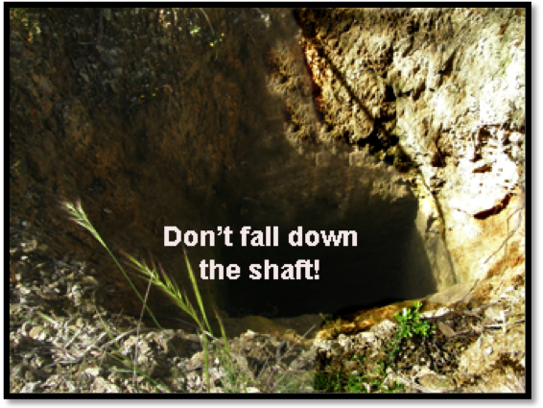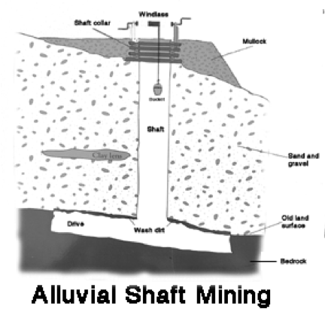

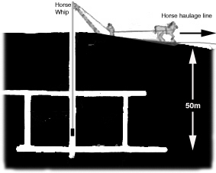Reef Gold

Quartz veins, or reefs, were the original sources of the gold. Once the alluvial gold had been mined, companies were formed to develop the reefs. The adjacent diagram shows a typical mine from which reef gold may have been extracted.

Gold bearing reef material was generally treated by horse puddler to remove clay, before being crushed by a stamp battery to separate the gold from the quartz**.**

1 On the diagram, label the shaft and the drives.

The map below shows the route we will take around the diggings and the locations we will study.

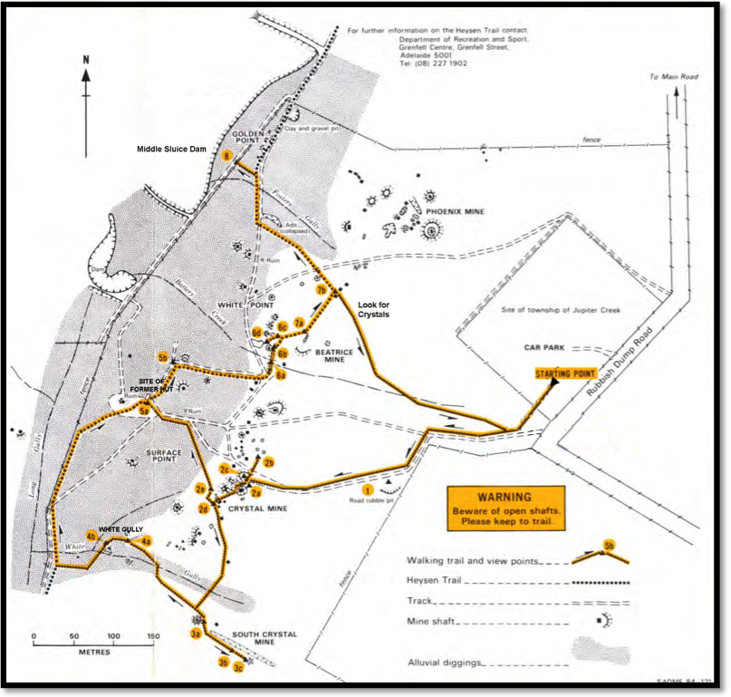

Our Route Around the Diggings

## Location 1 — Large Boulder

1 Name the rock type of which this boulder consists. __________________________________

2 a. Sketch the boulder in the space provided.

b. Label examples of the clasts and the matrix.

c. Identify the mineral that makes up many of the clasts.

______________________________________

d. Indicate on your diagram the approximate size of the boulder.

This rock was originally deposited in a river between 5 and 10 million years ago. It does not contain any gold, but it indicates the type of rock in which gold was mined at the bottom of the many small shafts you will see on your walk around the diggings.

## Location 2 — Crystal Mine (1884 to 1895)

Describe the following features of this mine and explain their functions.

2a Whip shaft

i. Description

___________________________________________________________________________

___________________________________________________________________________

ii. Explanation of Function

___________________________________________________________________________

___________________________________________________________________________

2b Horse haulage run

i. Description

___________________________________________________________________________

___________________________________________________________________________

ii. Explanation of Function

___________________________________________________________________________