2e Horse Puddler (1888)

The function of the horse puddler was to separate the gold from the clay with which it was mixed.

The photograph below shows the site of the puddler as it is today.

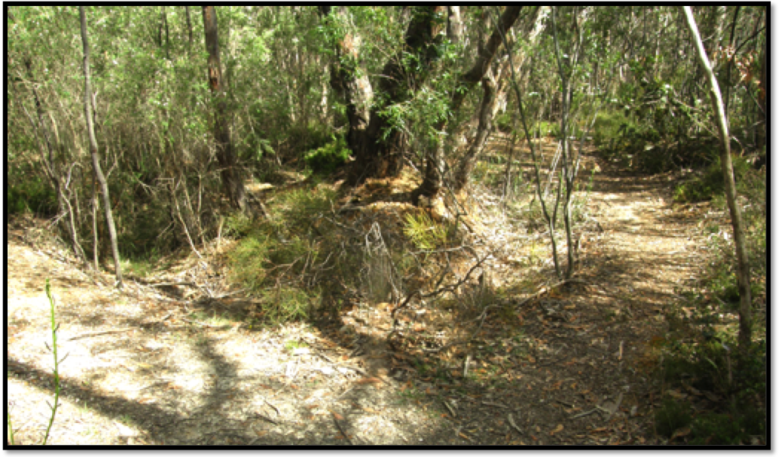

The Site of the Horse Puddler

i. Mark on the photograph the part of the puddler that has been best preserved.

ii. Why do you think this is the best-preserved part of the structure?

___________________________________________________________________________

___________________________________________________________________________

**We will not Visit Location 3.**

## Location 4 — Excelsior Adit and White Gully

4a. Excelsior adit was begun in the 1930s to prospect under the hill between the gully and Crystal Mine Reef. Owing to the hardness of the Quartzite, it was soon abandoned without intersecting any gold-bearing material.

i. A shaft and an adit both allow miners to enter an underground mine and remove the extracted materials from the mine.

Describe the main difference between an adit and a shaft.

___________________________________________________________________________

___________________________________________________________________________

ii. Which of the two mine entrances would be easier to construct? ____________________

iii Give a reason for your answer to part ii.

___________________________________________________________________________

___________________________________________________________________________

iv. In what situations would an adit be constructed, rather than a shaft?

___________________________________________________________________________

___________________________________________________________________________

White Gully was named after Mr. C. White who found alluvial gold here in 1868.

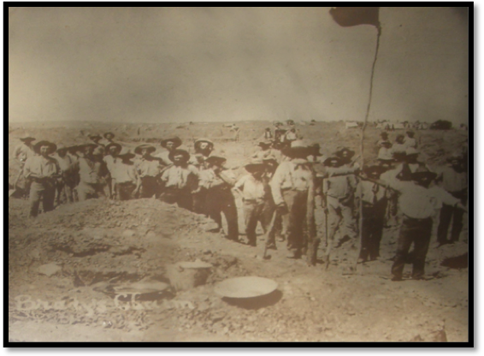

Diggers and their Equipment at an Alluvial Goldfield

4b i. From where would this alluvial gold have come?

______________________________

______________________________

ii. Explain why it would be found at this location?

______________________________

______________________________

iii. Would you expect to find alluvial gold at any other locations in the area? ________

iv. Give reason for your answer to part iii of this question.

___________________________________________________________________________

___________________________________________________________________________

v. Describe any evidence you can see of alluvial diggings operating at this location.

___________________________________________________________________________

___________________________________________________________________________

## Location 5 — Site of a Former Miner’s Hut

During the Depression years of the 1930s, the diggings were reworked. At location 5a there used to be a hut made by miners during the Depression. It was made from flattened bitumen drums. Unfortunately it was burned down in the Ash Wednesday bushfires of 1983.

Location 5b is the site of alluvial workings. Gold-bearing alluvial sand and gravel up to 5m below the surface were worked by short drives from the bottom of shafts.

5b Describe any remaining signs of the shafts and drives.

___________________________________________________________________________

___________________________________________________________________________

## Location 6 — Beatrice Mine (1869-1871)

The photograph below, although not of Beatrice Mine, shows what the mine might have looked like about 1870. Machinery and other facilities for treating the ore operated at this mine.

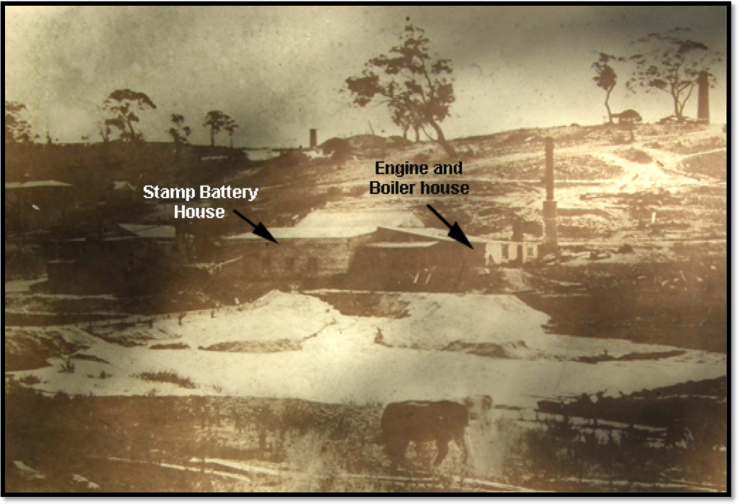

A mine that was probably similar to the Beatrice Mine

6a Describe any evidence you can see of the **dam** that was constructed to supply water for a boiler so that steam-powered machinery could operate.

___________________________________________________________________________

___________________________________________________________________________

6b What evidence can you see of the **Beatrice Engine Shaft** that was sunk to a depth of 30m in an attempt to locate a payable reef?

___________________________________________________________________________

___________________________________________________________________________

6c A **Circular Stone Chimney** provided an updraught for a boiler to which it was connected by an underground flue.

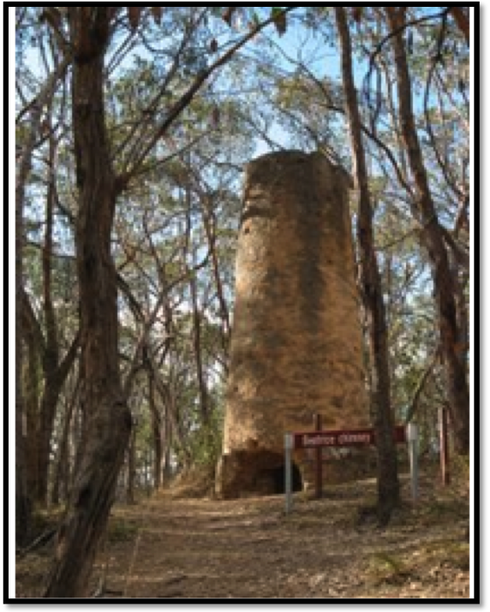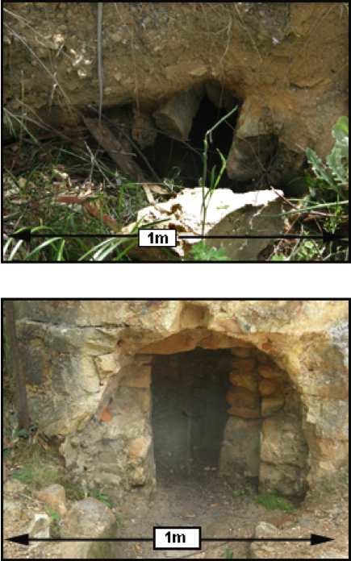

Two parts of the Flue, and the Mine Chimney

i. Describe the function of the chimney and flue combination.

___________________________________________________________________________

___________________________________________________________________________

___________________________________________________________________________

ii. Explain the significance of the chimney’s location.

___________________________________________________________________________

___________________________________________________________________________

iii. Suggest reasons why the parts of the flue have remained intact, instead of collapsing.

___________________________________________________________________________

___________________________________________________________________________

6d The site of the **Engine House**

Describe any evidence you can find that a large engine house once existed at this location.

___________________________________________________________________________

___________________________________________________________________________

6e i. How successful do you think the Beatrice Mine was?

___________________________________________________________________________

ii. On what evidence did you base your answer to the above question?

___________________________________________________________________________

## Location 7 — The New Pheonix Adit

This adit was excavated during the Depression years of the 1930s in a vain attempt to locate a gold reef. It now forms an optional section of the Heysen Trail.

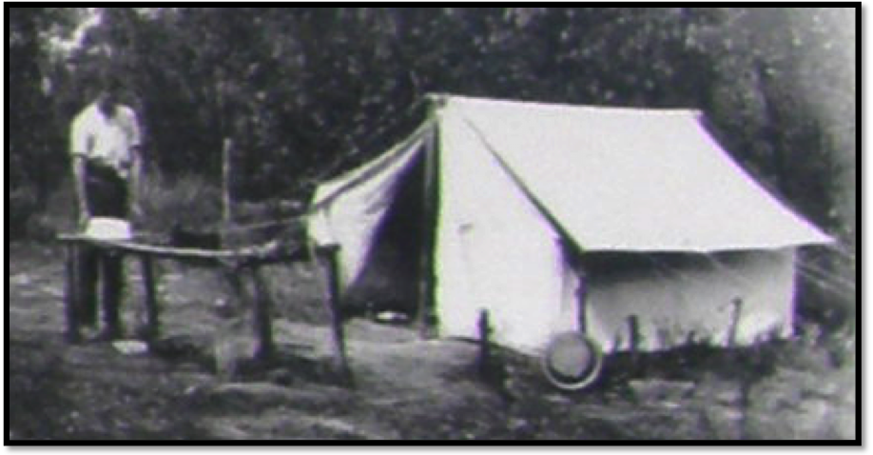

A Jupiter Creek Miner in 1930

You can enter the adit at location 7a and leave it, via an older mine shaft, at 7b. Apart from the entrance, it is high enough for people to walk upright.

**If you wish to explore this tunnel, you will need a torch and a hard hat.**

7 As you walk through the tunnel, stop and shine your torch on its walls.

i. Describe the appearance of the tunnel’s walls.

___________________________________________________________________________

ii. Touch the walls — what do they feel like?

___________________________________________________________________________

iii. What evidence is provided of how the tunnel was excavated?

___________________________________________________________________________

iv. State, giving reasons, whether this would have been an easy or a difficult task.

___________________________________________________________________________

___________________________________________________________________________

v. Comment on the presence or absence of any evidence that the miners found any gold.

___________________________________________________________________________

___________________________________________________________________________

## Location 8 — Middle Sluice Dam

When you come out of the mine, take the turning to the left that says **TO DAM**.

8 Just before you reach the dirt road at the end of the track, you will find the remains of an old dam. It no longer contains water.

i. Suggest the probable purpose of this dam.

___________________________________________________________________________

*Cross the road and look through the fence at Middle Sluice dam, which is much larger and does contain water.*

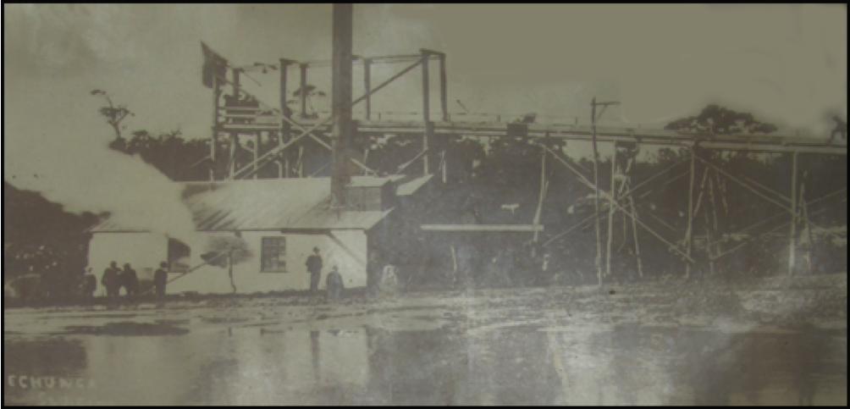

Sluicing Works, 1906

A company was formed in 1905 to treat the alluvial deposits around Golden Point on a large scale. Three dams were constructed and a barge containing a boiler, engine, pumps and washing plant was installed. The operation employed nearly 100 men. It closed down in 1908

ii. Suggest a reason why the company constructed such a large plant for extracting gold.

___________________________________________________________________________

___________________________________________________________________________

iii. Suggest why the plant closed down after operating for only three years.

___________________________________________________________________________

___________________________________________________________________________

iv. What probably happened to all that expensive plant?

___________________________________________________________________________

___________________________________________________________________________

*Return from the dam to the path junction near the Beatrice Mine (location 7b) and continue past the mine towards the car park.*

*About 50m past the junction with the track from Beatrice Mine, there is an area that has quartz fragments on the ground.*

If you search carefully amongst these fragments, you are likely to find quartz crystals.

In the space provided, draw examples of single quartz crystals, or of clumps of crystals. Give an indication of the size of each specimen you have drawn.

Examples of Quartz Crystals

*Return along the track to the car park.*

## What Do You Think?

1 Write about a paragraph describing an aspect of the geology and/or mining history you saw that you found interesting. Your paragraph should include the reasons why you found it interesting. Add any diagrams that would improve your answer.

___________________________________________________________________________

___________________________________________________________________________

___________________________________________________________________________

___________________________________________________________________________

___________________________________________________________________________

___________________________________________________________________________

___________________________________________________________________________

___________________________________________________________________________

2 Suggest some ways in which you think the excursion could be improved.

___________________________________________________________________________

___________________________________________________________________________

___________________________________________________________________________

___________________________________________________________________________

___________________________________________________________________________

___________________________________________________________________________

___________________________________________________________________________

___________________________________________________________________________