Lesson plan: Coconut fibre

Materials and equipment
General classroom items
Recording equipment
Recording books

Additional items.
Providing materials and equipment for each pair of students enables full participation.
Coconut fibre that has been soaking for at least an hour, but preferably overnight.

Plastic bowls (Explore)
Plastic cups (Elaborate)

Pop sticks to push the fibre under water (Elaborate)

Plastic jugs for cold water
Kettle(s) to warm water

Dry coconut fibre divided into approximately the same sized pieces (Elaborate)

Class “slops bucket” for all used fibre
Class washing tray for all used equipment
Old towels for mopping up spills

Science background.
Coconut fibre is removed from the coconut shell and bagged for garden use. Although some fibre is also “pressed” into circular inserts, the fibre that has not been processed is necessary for this investigation. It is possibly packaged in plastic bags.

Learning sequence.
Engage: Introduce coconut fibre and have students collect a small sample of both wet and dry.

Explore: Comparing coconut fibre
Students complete the table based on their observations.

Explain: The use of coconut fibre.

Evaluate: Science investigation What happens if coconut fibre is placed into water of different temperatures?
A simple investigation based on changing the temperature of the water.
If a fridge is available then slightly colder than tap water could be used. Students can collect and pour cold water.
SAFETY CONSIDERATION: Warm water should be poured by an adult and students told not to move the cup. The temperature of this water will drop fairly quickly.
Aim to have students place their coconut fibre into both cups of water at the same time. This will enable a more accurate comparison. Students are encouraged to stir and move their fibre within the cups.

Evaluate: Cass discussion of their observations, student participation and recording.

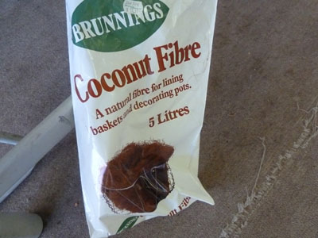 | 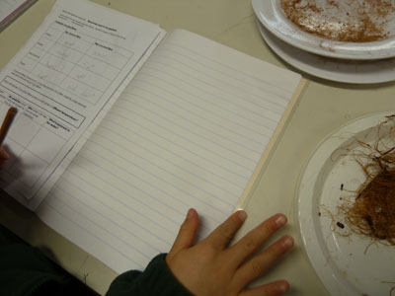
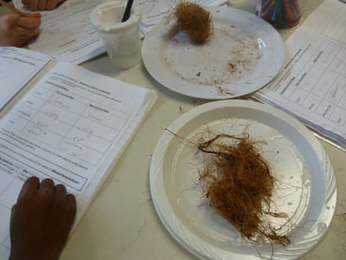 | 