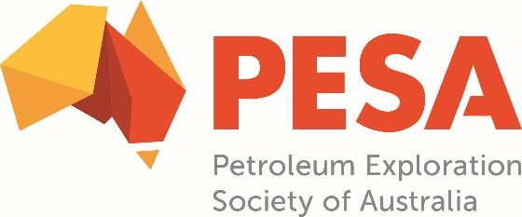

The Petroleum Exploration Society of Australia (PESA) is a national organisation promoting professional and technical excellence in energy geoscience.

Upstream professionals join today and receive the following benefits:

TECHNICAL MEETINGS

Discount rates for regular technical meetings featuring high-quality speakers providing opportunity to gain new knowledge, and network with others.

ONLINE TECHNICAL CONTENT

Free access to PESA webinars and access to the Knowledgette platform with online content sourced from AAPG, SEG, SPWLA and CSPG.

PESA NEWS MAGAZINE
Free quarterly magazine keeping you abreast of exploration, events, members movements and activities of interest in the oil and gas sector.

NETWORKING EVENTS
Discount rates for regular networking and social events to foster development of connections amongst colleagues.

PESA TECHNICAL LIBRARY

Free unlimited access to the PESA Technical Library - a comprehensive collection of PESA publications and conferences over the past 50 years.

SHORT COURSES
Discount rates on PESA short courses as well as exclusive partner discount rates on PetroEdge courses held in Australia and Geologize’s Practical Geocommunication.

CONFERENCES

Discount rates for leading conferences including AEGC, WABS, EABS, CABS, APPEA and AGCC, plus, reciprocal member delegate rates at selected affiliate society events.

To start realising your member benefits visit pesa.com.au

