Earth systems studies
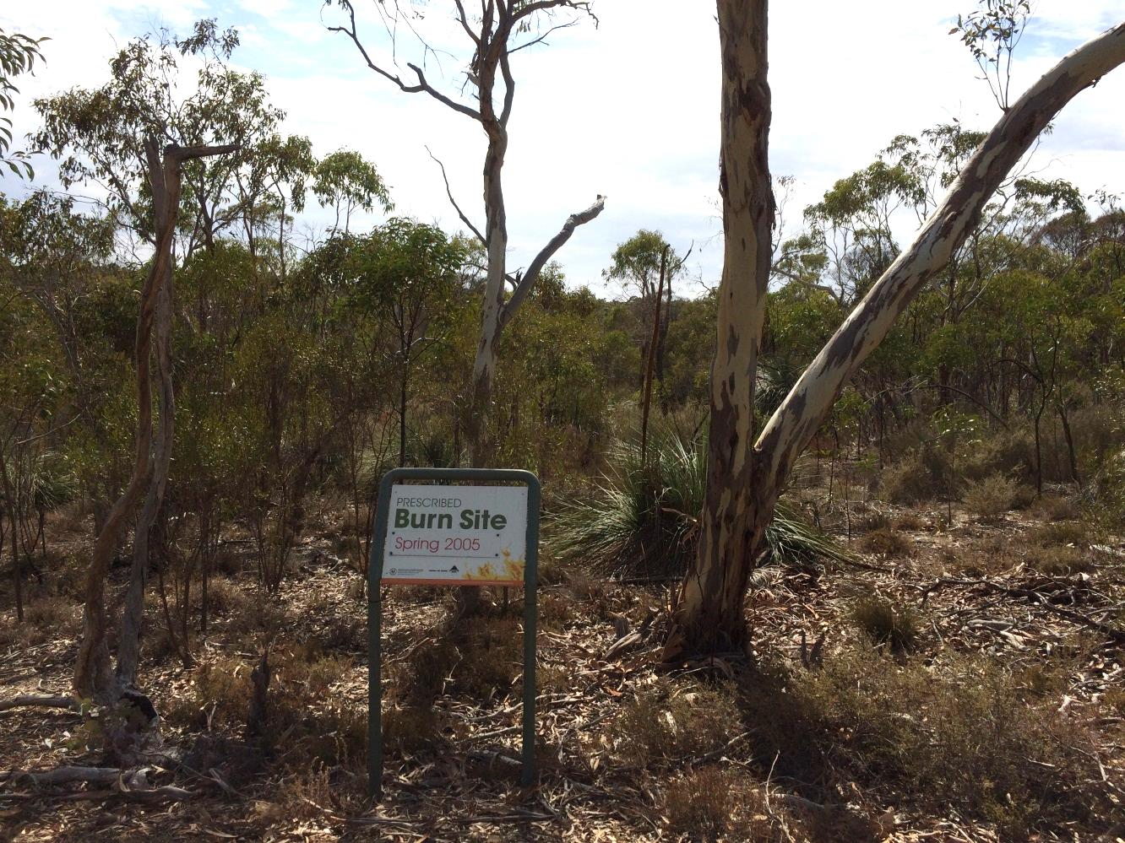The following are brief overviews of possible senior secondary field-based projects that could be undertaken in South Australian National Parks, as part of the SACE Earth and Environmental Science course.
Fourteen years after a bush fire, this forest appears similar to unburnt land. Para Wirra Conservation Park, Humbug Scrub, South Australia.

Para Wirra Conservation Park
Para Wirra Conservation Park is located in the northern Mount Lofty Ranges in-between the towns of Kersbrook and Gawler. The park adjoins two reservoirs, Mount Crawford Forest and the Humbug Scrub Wildlife Sanctuary. Together this collective of spaces comprises 2,5703 Hectares of contiguous forest, vegetation and fuel for fire.
Issue #1
Fire has been used by Aboriginal people to farm and manipulate the Australian landscape for thousands of years.
Today, fire is still used by national park rangers and fire management staff to influence the density and amount of vegetation within national parks.
Fire is an important part of park management. Many Australian plants require the heat and/or smoke from a fire in order to germinate. Fire has the ability to reduce fuel load and to stimulate renewal of landscapes.
Prescribed burns are fires that are deliberately lit within national parks and on private land to reduce fuel loads.
The reduction of fuel load within a particular area helps to reduce the risk of a bushfire by removing leaf litter, vegetation and canopy cover within the prescribed burn area.
Bushfires that occur on hot, dry and windy days are difficult to control.
The benefit of using prescribed burns to reduce fuel load are that if and when a fire reaches an area that has been recently burnt, the fire does not have as much fuel to burn and hence may reduce in severity or burn out.
This may allow the fire to be better controlled by fire management staff.
Ecologists, park rangers and fire management staff investigate particular areas to burn that won’t have a hugely negative effect on populations of animals and other biota living in the area.
Conservation values, habitat and the ecology of a system are researched and thought of before a burn is planned and commenced.
Burning areas frequently can greatly reduce animal populations and biodiversity.

For more information

Effects of fire on natural landscapes and management plans to help control the effects of invasive species

National Parks SA Ranger, Peter Hannon

E: peter.hannon2@sa.gov.au

Aislinn.McAleer@sa.gov.au
Learning in National Parks
NRM Education Officer, Julian Marchant
E: jmarchant@salisbury.sa.gov.au
www.naturalresources.sa.gov.au/
adelaidemtloftyranges
It is essential to adequately plan for prescribed burns to reduce the risk of damage to a system.
Burning can alter soils, water, air quality, flora and fauna.
A fire scar can be seen on the main road in Para Wirra Conservation Park. This area is sign posted.
Study area
EES students will visit Para Wirra Conservation Park to investigate the effects of fire on the Para Wirra ecosystem, water and soil.
Students will compare areas of unburnt vegetation compared to recently burnt areas and areas burnt 10-20 years ago, recording information on plant density, the diversity of species, canopy cover and diversity of storey layers.
Issue #2
Adelaide’s average temperature is expected to increase by 0.6°C–1.3°C by 2030 as compared to 1990. This is coupled with an expected doubling of the number of days over 35°C compared to the long-term average by 2070.
South Australia is projected to experience increases in time spent in drought.
How is this likely to affect the amount and severity of fires within the Mount Lofty Ranges and more specifically at Para Wirra Conservation Park?

Study area

The effects of climate change on the frequency and severity of bushfires/wildfires across the greater Mount Lofty Ranges will be investigated, utilising climate change predictions and trends and bushfire data. Students will investigate the effect that fire currently has on the habitat value of vegetation within the park and the effects that changes to future fire regimes may have on the value of the ecosystem as habitat for a chosen species in the future.

