# Year 9 Plate Tectonics Unit

# Answers to Student Booklet

## *Note that the answers given below are not the only possible correct answers to many of the questions.*

## The Plate Tectonics Theory

1 Earthquakes and volcanoes

2 Earthquakes

3 In the middle of a plate

4 *See table below*

|  |  |
| --- | --- |
| **NAME OF PLATE** | **MOST SIGNIFICANT LANDMASSES AND/OR OCEANS** |
| Pacific Plate | Pacific Ocean |
| Australian Plate | Australian Continent |
| Eurasian Plate | Eurasia |
| North American Plate | North America |
| South American Plate | South America |
| Antarctic Plate | Antarctica |
| Nazca Plate | Pacific Ocean |

## Evidence for Plate Tectonics

1 *The wording does not have to be exactly the same as that given in the answers.*

Figure 2 — Matching of Continental Edges

Figure 3— Matching Rock Units on Different Continents

Figure 4 — Fossils found in different parts of Gondwana

## Alfred Wegener 1880 - 1930

1 Matching coastlines of the Atlantic continents: matching rock types, structures and fossils.

2 His ideas were radically different from the beliefs of the time: geologists were resistant to change.

3 Harry Hess proposed the mechanism sea-floor spreading, which explained how the continents moved: newly discovered exploration techniques supported this theory

## Activity 1 — Moving Continents Puzzle

At the end of this booklet there is a map of two imaginary continents.

1 Matching edges of continents: matching rock types..

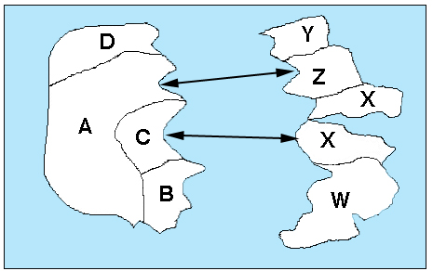2 a. *See diagram below*

b. The rock types immediately opposite each other on the two continents have been found to be almost the same age.

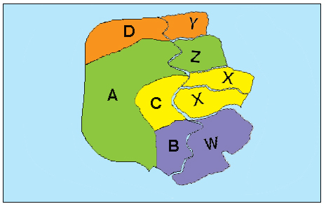

3 *See diagram below*

4 D, 4.0my: W, 1.5my

## Features of he Earth’s crust and Interior

1 See figure, 5, p6 of Background Information for Teachers

## Activity 2 — Convection Currents in Water

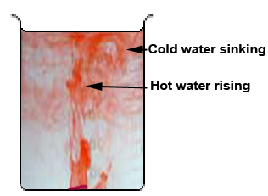7. *The adjacent diagram shows a typical pattern of rising and sinking coloured water*.

### Discussion

1. It started to rise in the beaker.

2 It started to sink.

3 Hot liquids rise. Cooler liquids sink.

## Convection currents in the Earth’s Mantle

1, 2 and 3 — *See diagram below*

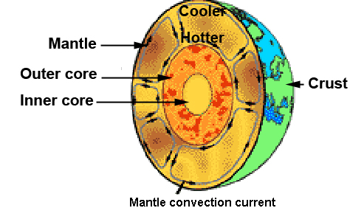

## A Variety of Plate Boundaries

1 *See figure 7, p7 of Background Information for Teachers.*

2 *See figure 8, p8 of Background Information for Teachers.*

3 *See figure 7, p7 of Background Information for Teachers.*

4 *See figure 9, p9 of Background Information for Teachers.*

## Activity 3 —Analysis of a Plate Boundary

2 a. Most of them lie on the plate boundaries.

b. Nearly all of them lie on plate boundaries.

3 b. *The answers below are for one particular date only.*

|  |  |  |  |
| --- | --- | --- | --- |
| **Latitude (S)** | **Longitude (W)** | **Depth (km)** | **Magnitude** |
| 5.6 | 80.9 | 9.8 | 6.3 |
| 19.8 | 70.6 | 35 | 7.0 |
| 33.6 | 72.1 | 9.3 | 5.7 |

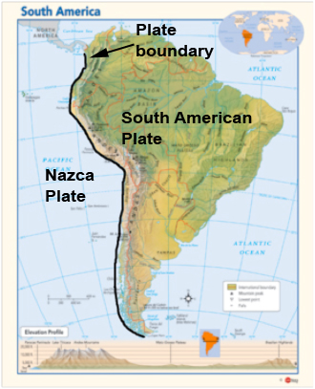

4 a, and b. *See adjacent map.*

c. They are almost parallel to each other.

d. They must be almost the same.

e. Yes.

5 *See graph on the next page.*

6 a. Shallow.

b. They get deeper.

7. a. Subduction zone.

b. It is descending below the South American Plate.

c. Deep below the ground, possibly melting into the mantle.

Graph for question 5.

## Activity 4—A Virtual Earthquake

This activity is carried out on line, and the answers are provided.

## Ages of Oceanic and Continental Crust

1 *See figure 11, p10 of Background Information for Teachers.*

2 a., b. and c. *See diagram below.*

Also, a divergent and b. convergent.

3. and 4 *See figure 13, p12 of Background Information for Teachers.*

### Ans to Earthquake and volcano locations.jpgPlate Tectonics and Australia Though Time

1 a. None

b. None

2 i. There are no active volcanoes. ii. There are no severe earthquakes (magnitude >7).

3 *See figure 14, p13 of Background Information for Teachers.*