3 a. Click on one of the circles representing recent earthquakes along the western coast of South America, south of 15° S latitude and north of 35° S latitude. A page of information about this earthquake will open.

b. Using the information in the **Earthquake Info** box, record the magnitude, latitude (first number in Location), longitude (second number) and depth, in the data table below.

Record the same information for up to two more earthquakes along this coast.

|  |  |  |  |
| --- | --- | --- | --- |
| **Latitude (S)** | **Longitude (W)** | **Depth (km)** | **Magnitude** |
|  |  |  |  |
|  |  |  |  |
|  |  |  |  |

4 The data table below lists information for other earthquakes along the same portion of the South American and Nazca plate boundary.

|  |  |  |  |
| --- | --- | --- | --- |
| **Latitude** | **Longitude** | **Distance from Sea Level (km)** | **Magnitude** |
| -23.06 | -70.59 | -16.8 | 6.4 |
| -23.17 | -70.12 | -36 | 6.4 |
| -16.09 | -69.99 | -62 | 6.6 |
| -29.67 | -69.38 | -71 | 6.4 |
| -21.75 | -68.78 | -101.2 | 6 |
| -19.99 | -68.6 | -115.5 | 7.8 |
| -18.3 | -68.53 | -133.8 | 6.2 |
| -16.12 | -68.0 | -136.2 | 6.1 |
| -23.37 | -67.69 | -147.4 | 6 |
| -22.32 | -67.89 | -162.6 | 6.9 |
| -20.93 | -67.28 | -218 | 6.4 |
| -23.54 | -66.45 | -225 | 7.2 |
| -22.98 | - 66.3 | -256.2 | 6.1 |
| -22 | -65.72 | -276.2 | 7.1 |

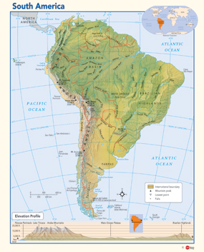 a. By referring to figure 1 of this booklet, sketch the boundary between the Nazca Plate and the South American Plate on the adjacent map of South America below.

b. Label the Nazca Plate and the South American Plate.

c. What do you notice about the relation between the longitude lines and the direction of the plate boundary that is close to the southern part of the continent?

________________________________________________________________________________________________________

d. What can you infer from your answer to part b. about the longitudes of any earthquakes on this plate boundary?

______________________________________________________________________________

c. Do the longitude values of the earthquakes in the above table support your answer to part c?

______________________________________________________________________________

5 Using the data in the appropriate columns of the above table, construct a graph, using paper and pencil or a computer program, which shows the relationship between the *longitude* of the earthquakes and their *distance from sea level.*

N.B. Plot distance from seal level on the y-axis of your graph. These distances are all below sea level, and are therefore negative.  The numbers for longitude are also negative because they are west of the prime meridian. This means that the zero line is to the east.

If you are plotting your graph using paper and pencil, put the origin of your graph at the top right hand corner and choose the following scales:

x-axis — longitude — start at 65° and use 1cm:0.25°.

y-axis — depth — start at zero and use 1cm:20km.

6 a. At the western portion of your plot, at what depths do earthquakes occur?  ____________

b. As you move to the east, what happens to the depth of the earthquakes?

______________________________________________________________________________

7 a. Most earthquakes occur along plate boundaries. What type of plate boundary does the one on the west edge of South America represent?

______________________________________________________________________________

b. Describe the processes that are happening to the Nazca plate over time.

______________________________________________________________________________

______________________________________________________________________________

c. Consider sample of basalt that is now on the surface of the Nazca Plate where it meets the South American Plate. Where would that sample be in a few million years?

______________________________________________________________________________

d. On your graph, indicate the positions of the two plates.

e. Add arrows to your graph to show the directions in which the plates are moving.

**Glue your graph onto the next page, which has been left blank**

**Activity 4—A Virtual Earthquake**

**Glue your graph onto this page**

**This activity is carried out using the Internet.**

You will discover how earthquake epicentres are located

1 Locate the site with the following URL:

<http://www.sciencecourseware.org/VirtualEarthquake/>

2 Click on the following button to begin your virtual earthquake analysis:

3 You are given a choice of locations. Chose **Japan** **region** and click on **submit choice**



4 Read the following information about measuring the S-P interval for earthquake waves.

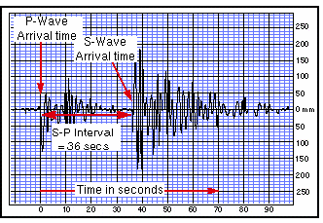 The site where an earthquake actually occurs is below the Earth’s surface and is called its **focus.** The position on the Earth’s surface above the focus of the earthquake is called its **epicentre.**

In order to locate the epicentre of this earthquake, you need to estimate the time interval between the arrival of two different types of earthquake waves, known as P-waves and S-waves, (the S-P interval) on the seismograms from three different stations. You have to measure the interval to the closest second and then use a graph to convert the S-P interval to distance from the epicentre. On the sample seismogram at the right the vertical lines are spaced at 2-second intervals and the S-P time interval is about 36 seconds.

5 Click **view seismograms**

You will see seismograms produced by one earthquake, but received at three different earthquake recording stations.

Measure the distances between the P and S waves in the three seismograms shown and enter your results in the boxes below each seismogram.

6 Click **Convert S—P Interval.**

Use the graph at the bottom of your screen to find the distance from the epicentre of each of the recording stations. Fill in the table next to the graph.

 Click on button **Find Epicentre**.

7 Take a screen shot of your plotting of the epicentre from the three stations. Cut it out from the sheet of paper and glue it into the space provided on the next page. Label it **Epicentre Plotting**.

8 Click on the button labelled **Compute Richter magnitude**

**Glue your Epicentre Plotting diagram here.**

The Richter magnitude of an earthquake is an estimate of the total amount of energy released during fault rupture. Its value is found from measurements made on seismograms. Two measurements are needed: the S-P time interval and the Maximum Amplitude (size) of the Seismic waves. You already know how to measure the S-P interval.

The illustration below shows you how to make the measurement of the S-wave's maximum amplitude. The blue horizontal grid lines are spaced at 10mm. In this example the maximum amplitude is about 185 mm.

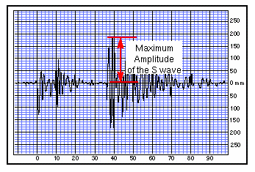

9 Click **Go To Next Page**

Don’t worry about the information on that page. Just click **GoTo Next Page** again**.**

Measure the amplitudes of the three sets of waves. Record your results in the boxes below the seismograms.

10 Click **Submit To Nomogram**



You will see Richter's nomogram with three lines representing the data you provided. The Richter magnitude of this earthquake is given by the location on the magnitude scale where your three lines should meet. However, your three lines might not cross at a point on the magnitude scale or even meet at a single point. Enter your estimated magnitude in the box below the nomogram.

Make a screen shot of your nomogram, cut it out from the sheet and glue it in the space provided below.

Your estimated magnitude is ___________

**Glue your nomogram here**

11 Click **Confirm Magnitude**



The actual magnitude of the earthquake was ____

12 Complete the form to receive a Certificate of Completion as a Virtual Seismologist.

