# Australian Curriculum Requirements

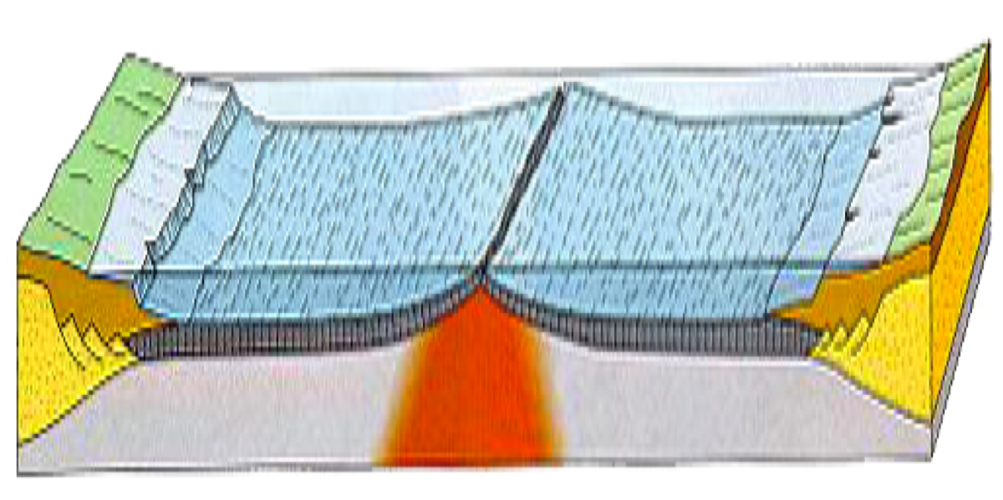

### Year 9 Science — Earth and Space Science

### Understanding — Content Description

### The [theory](http://www.australiancurriculum.edu.au/Glossary?a=S&t=Theory) of plate tectonics explains global patterns of geological activity and continental movement [(ACSSU180)](http://www.australiancurriculum.edu.au/Curriculum/ContentDescription/ACSSU180)

### Elaborations

recognising the major plates on a world map

modelling sea-floor spreading

relating the occurrence of earthquakes and volcanic activity to constructive and destructive plate boundaries

considering the role of heat energy and convection currents in the movement of tectonic plates

relating the extreme age and stability of a large part of the Australian continent to its plate tectonic history

### Literacy

The particular elements of Literacy addressed by this content description

Comprehending texts through listening, reading and viewing

Interpret and analyse learning area texts

Comprehend texts

Navigate, read and view learning area texts

Word Knowledge

Understand learning area vocabulary

### Critical and creative thinking

The particular elements of Critical and creative thinking addressed by this content description

Inquiring – identifying, exploring and organising information and ideas

Identify and clarify information and ideas.

### Science as a Human Endeavour

*The history of the development of the concept of Plate Tectonics presents a very good example of the Nature and Development of Science, within the context of Science as a Human Endeavour.*

It can be used to show that:

* Scientific understanding, including models and theories, are contestable and are refined over time through a process of review by the scientific community
* Advances in scientific understanding often rely on developments in [technology](http://www.australiancurriculum.edu.au/Glossary?a=S&t=Technology) and technological advances are often linked to scientific discoveries.

## Description of this Unit

This Unit contains the following sections:

1. Background information for teachers who have little knowledge of the Earth Sciences.

2. Student booklet, that includes:

i Information about the topic, including some history of the development of the Plate Tectonics Theory

ii Worksheets

iii Instructions for some ‘Hands on’ activities’

iv Questions to test students’ understanding of the concepts.

v Suggestions for research topics requiring critical and creative thinking.

3. A teacher’s copy of the Student Booklet, containing answers to all questions posed and may contain further details about the hands-on activities

4 A catalogue of suitable AV materials.

Some of these are available for schools to loan.

5 A DVD showing a range of ‘hands-on’ activities being carried out.

6 Working models that are large enough to show to a whole class. These would demonstrate continental drift, as well as processes occurring at the different plate boundaries. They could be loaned to schools as needed.

# The Plate Tectonics Theory

The plate tectonics theory encompasses the following major ideas:

**• The layer of the Earth we live on is broken into a dozen or so rigid slabs, called tectonic plates. They are moving relative to each other.**

**• Earthquakes and volcanoes occur on the edges of tectonic plates because the plates are moving.**

**• Most plate boundaries occur in the oceans, or on the ocean-continent margins, but some plate boundaries are on continents.**

• **At the boundaries, the plates** **can grind sideways past each other, slide underneath each other or move away from each other.**

• Distinctive tectonic features occur at each type of boundary.

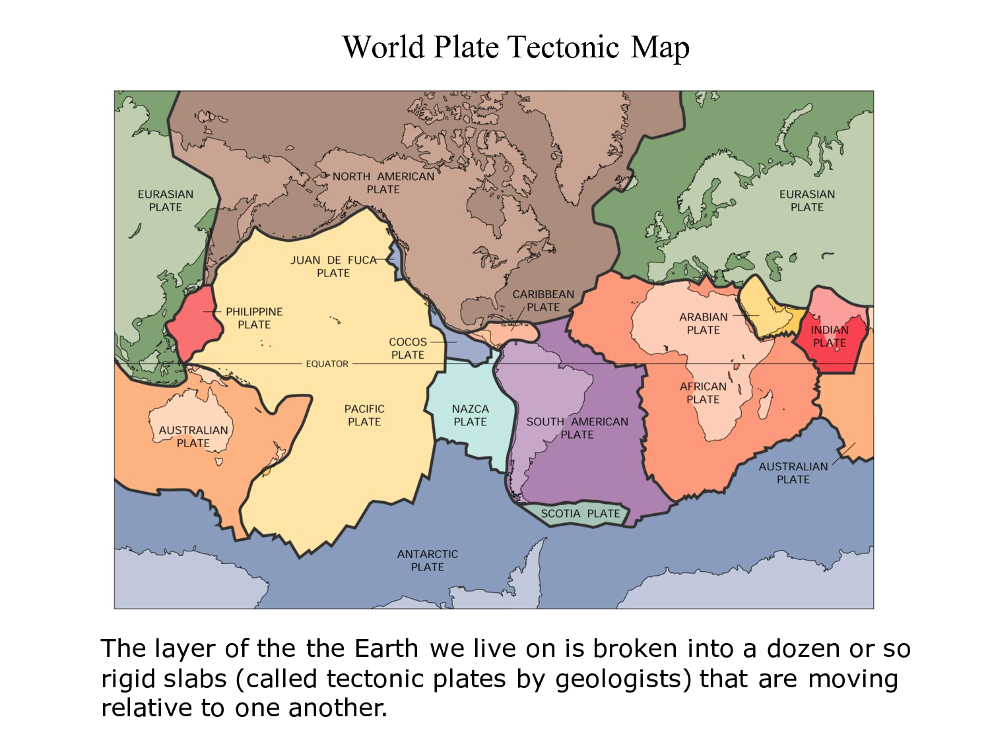Figure 1 shows the names and locations of the Earth’s major plates.

Figure 1 — The Earth's Major Plates

Ref: http://www.docstoc.com/docs/123448255/World-Plate-Tectonic-Map

## Evidence for Plate Tectonics

Ever since the seventeenth century, several lines of evidence have suggested that the continents have not always occupied their present positions on the Earth’s surface. Major forms of evidence include: jig-saw fit of continents, matching rock types on different continents and similar fossils found on continents that are now widely separated.

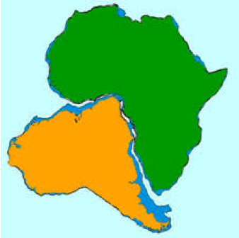

Figure 2 — Matching of Continental Edges

Ref: http://www.open.edu/openlearn/science-maths-technology/science/geology/what-plate-tectonics

From the time that the first maps of the Atlantic Ocean were made, people noticed that the boundaries of South America and Africa would fit together, like the pieces of a jig-saw puzzle. This is shown in figure 2, which also indicates that it’s the edges of the continental shelves that match, rather than the shorelines of the landmasses.

Rock types and geological structures, such as fold mountain ranges, also continue from one continent to another, although the continents are now many thousands of kilometres apart. For example, Figure 3 shows the relative positions of Australia, Antarctica and India about 165 million years ago. Matching rock types, indicated by their colours, are found today on the margins of the three continents provide evidence for this reconstruction.

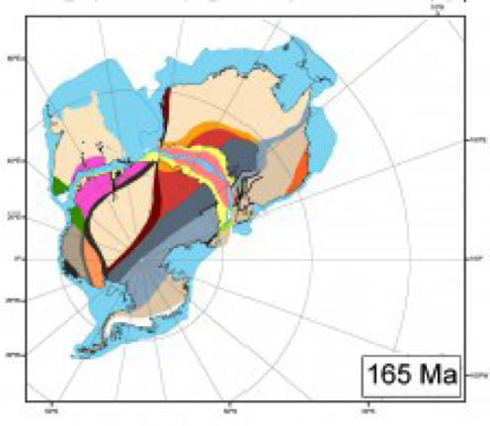

Figure 3 — Matching Rock Types on Different Continents

*Adapted from* http://www.decodedscience.com/continental-drift-new-study-reviews-the-position-of-continents-after-the-breakup-of-gondwana/31909/2

Figure 4 shows that fossils of several land-living organisms have been found on continents that are now separated by oceans. It also shows how those continents fit together and probably formed a large landmass that is now known as Gondwana.

### Alfred Wegener 1880 - 1930

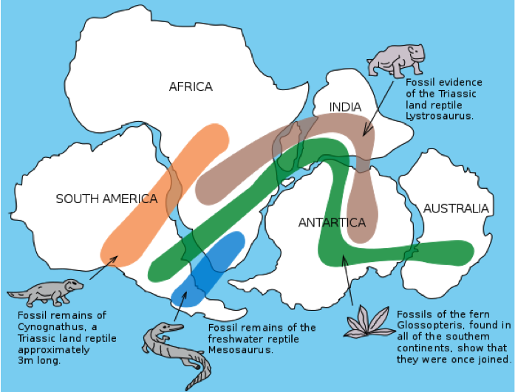

Figure 4 — Fossils found in different parts of Gondwana

*Source:* http://en.wikipedia.org/wiki/File:Snider-Pellegrini_Wegener_fossil_map.svg

Alfred Wegener was born in Berlin in 1880. He studied in Germany and Austria, receiving his PhD in astronomy.

In 1910, Wegener noticed the matching coastlines of the Atlantic continents — they looked on maps as if they had once fitted together. He was not the first to notice this, but it was an idea that would never leave his thoughts. He pursued his studies of the continents and he presented his Continental Drift hypothesis on January 6, 1912. He had analysed either side of the Atlantic Ocean for rock type, geological structures and fossils. He noticed that there was a significant similarity between matching edges of the continents, especially in [fossil plants](http://en.wikipedia.org/wiki/Fossil_plants).

He published his ideas in 1915, in ‘The Origin of Continents and Oceans’. They constituted the first focused and rational argument for continental drift, arguing that all the continents were once joined together in a single landmass and have drifted apart. Wegener also speculated on [sea-floor spreading](http://en.wikipedia.org/wiki/Sea-floor_spreading) and the role of the [mid-ocean ridges](http://en.wikipedia.org/wiki/Mid-ocean_ridge), stating: the Mid-Atlantic Ridge ... zone in which the floor of the Atlantic, as it keeps spreading, is continuously tearing open and making space for fresh, relatively fluid and hot molten rock from depth. However, he did not pursue these ideas in his later works.

Wegener’s ideas veered radically from the accepted beliefs of the time. Some scientists supported him, but more opposed him. Although Wegener had presented a large amount of observational evidence in support of continental drift, the [mechanism](http://en.wiktionary.org/wiki/mechanism) remained elusive. The hypothesis was initially met with skepticism from geologists who viewed Wegener, a meteorologist, as an outsider. They were also resistant to change. The established reputations of many of his detractors probably gave more weight to their criticisms than was merited. Wegener often complained of their narrow-mindedness

Well after his untimely death in 1930, and after World War II, Wegener's theories were vindicated by the work of Harry Hess and others. In 1960 Hess proposed the mechanism of sea-floor spreading, which would explain how the continents moved. Newly discovered exploration techniques were employed to support this theory and ultimately, the correctness of Wegener's chief idea as well

There are many U-tube videos about Alfred Wegener. Students would be amused by this one:

http://www.youtube.com/watch?v=T1-cES1Ekto

### The Earth’s Interior

The Earth has a layered structure, as shown in figure 5. The outermost layer is the crust, which is the solid surface we live on. There are two distinct types of crust — oceanic and continental. Both types of crust are divided into tectonic plates, while the mantle controls the movements of these plates.

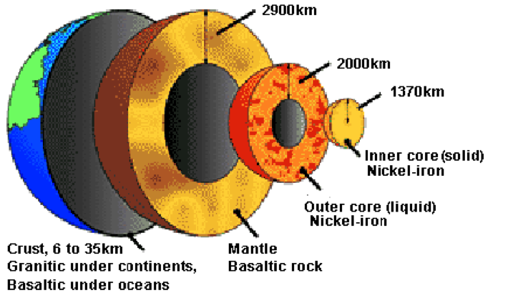

Figure 5 — Structure of the Earth's Surface and Interior

*Adapted from*: http://www.heritage.nf.ca/environment/geology.html

The mantle is solid, but over very long periods of time most of it behaves like plasticine and flows. Heat, generated by radioactive decay and gravitational friction, keeps part of the mantle soft. Molten rock (magma) rises towards the surface of the Earth, cools, and sinks to be reheated far below. The temperature difference between the top and bottom of the mantle causes a circular flow called convection. Convection currents stir this semi-fluid layer. The uppermost mantle and crust form an outer shell of rigid plates. The plates, and the continents they contain, move across the Earth's surface on the convection currents. Figure 6 illustrates the convection currents in the mantle.

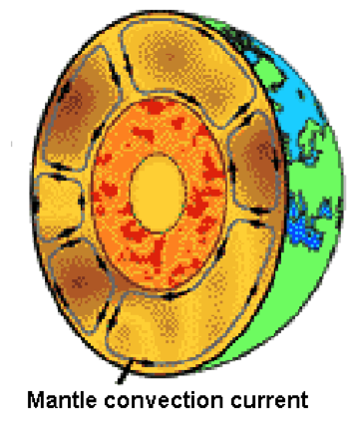

Figure 6 — Convection Currents in the Earth's Mantle

*Adapted from*: http://www.heritage.nf.ca/environment/geology.html

There is a good demonstration of convection currents at:

http://www.youtube.com/watch?v=WEDUtS0IMws

### Mid-ocean Ridges — Constructive Plate Boundaries

Figure 7 shows the sea floor as we would see it if there was no water in the oceans. A mid-ocean ridge is a general term for an [underwater](http://en.wikipedia.org/wiki/Underwater) [mountain system](http://en.wikipedia.org/wiki/Mountain_range) that consists of various mountain ranges (chains), typically having a [valley](http://en.wikipedia.org/wiki/Valley) known as a [rift](http://en.wikipedia.org/wiki/Rift) running along its spine. All the mid-ocean ridges of the world are connected, and they form a single global mid-oceanic ridge system that is part of every ocean. The mid-oceanic ridge system is the longest mountain range in the world, with a total length of about 80,000 km. It can be seen from figure 7 that some of the mid-ocean ridges are not actually in the centres of the oceans. For example, the mountain chain in the Pacific Ocean is also known as the East Oceanic Rise.

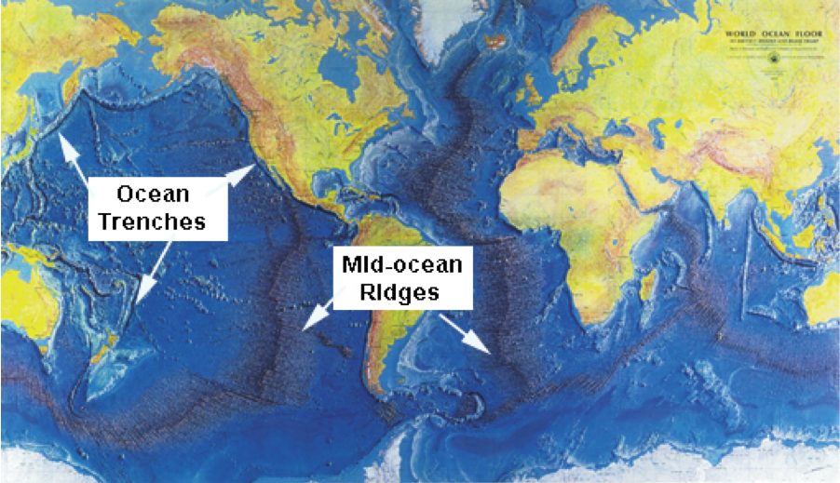

Figure 7 — Features of the Ocean Floor

*Adapted from:* http://earthguide.ucsd.edu/eoc/teachers/t_tectonics/p_midoceanridges.html

Mid-ocean ridges are **constructive**, plate boundaries. New lithosphere is formed by eruption of basaltic magma at these boundaries, and the plates are moving apart at approximately 5cm a year. The ridges contain rift valleys where magma is welling up from the mantle and solidifying to form new oceanic crust. They are areas where basaltic volcanoes are common, and shallow-focus earthquakes occur due to the movement of upwelling magma. The mid-Atlantic ridge rises above sea level in **Iceland**, Figure 8 shows how new oceanic crust is formed at mid-ocean ridges.

Addition   of   new   oceanic crust forces  plates  away  from  each other,  thereby  separating  and   moving  the  continents.

As shown in figure 8, the Earth’s crust and upper mantle consist of two layers, known as the **lithosphere** and the **asthenosphere.**

**The lithospere is made up of the crust, which is about 35km thick and the upper 100m of the mantle. It consists of hard, brittle rock. The asthenosphere comprises the next 100km of the mantle.** It consists of rock in a semi-molten (plasticine-like) state, which is constantly being stirred by convection currents.

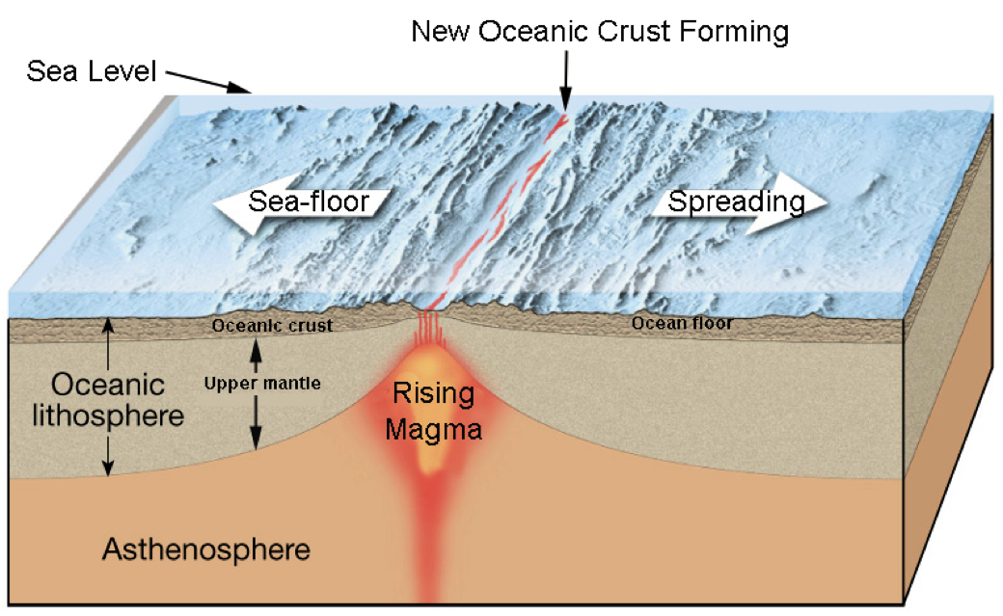

Figure 8 — Formation of new Oceanic Crust at a Mid-ocean Ridge

*Source:* Adapted from http://oceansjsu.com/105d/exped_commotion/2.html

### Destructive Plate Boundaries

Since new oceanic crust is continually being formed at constructive plate boundaries, old oceanic crust must be destroyed elsewhere, because the Earth is not getting any larger.

**Destructive** plate boundaries are also known as **subduction zones**, which are regions where one plate is dipping, or subducting, under another and lithosphere is being destroyed. Convection currents in the asthenosphere carry the sea floor in a conveyor-belt  fashion to the deep-ocean trenches, where the sea floor descends into the mantle and eventually melts to become part of the mantle

Destructive boundaries may exist between:

* Two oceanic plates
* An oceanic plate and a continental plate
* Two continental plates

Earthquakes are likely to occur at all three types of destructive boundary, while volcanoes are common at boundaries involving oceanic plates. Figure 9 shows how oceanic crust is destroyed at an example of these boundaries. In this case, an oceanic plate is being destroyed by subduction under a continental plate. The west coast of South America is an example of this type of boundary, forming the Andes mountain range.

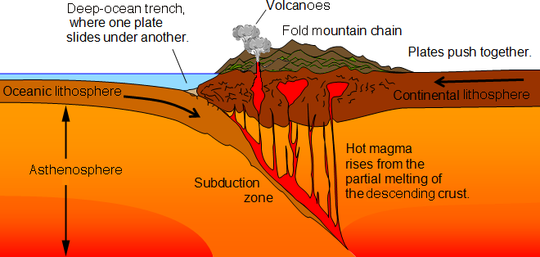**Figure 9 — A Destructive Boundary Between an Oceanic Plate and a Continental Plate**

*Source:* adapted from <http://geography.parkfieldprimary.com/hazards/plate-tectonics>

Volcanoes occur at these boundaries because the subducting plate melts as it travels deeper into the hot mantle, and the magma rises to be erupted from the Earth’s surface above the subduction zone. Deep- and shallow-focus earthquakes are caused by friction between the subducting plate and the mantle into which it is moving. Compression forces between the two plates cause fold mountain ranges to form

When two oceanic plates collide, magma from the subducting plate erupts at the Earth’s surface to form an arc of volcanic islands, such as the Philippines. When plates are colliding under the sea, earthquakes are likely to occur under the sea, giving rise to destructive tsunamis.

### Conservative Plate Boundaries.

No crust is created or destroyed at conservative boundaries between two plates. The plates just slide past each other, as shown in figure 10. No volcanic activity occurs at these boundaries, but earthquakes are caused by friction between the plates as they slide past each other.

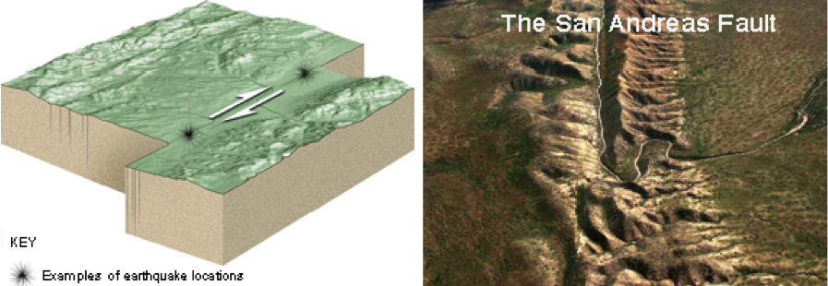

Figure 10 — A Conservative Plate Boundary

*Source:* Adapted from http://extremeearth.net/education/lithosphere/

## Ages of Oceanic and Continental Crust

Figure 11 shows the locations and activities of both constructive and destructive place boundaries in the Pacific Ocean.

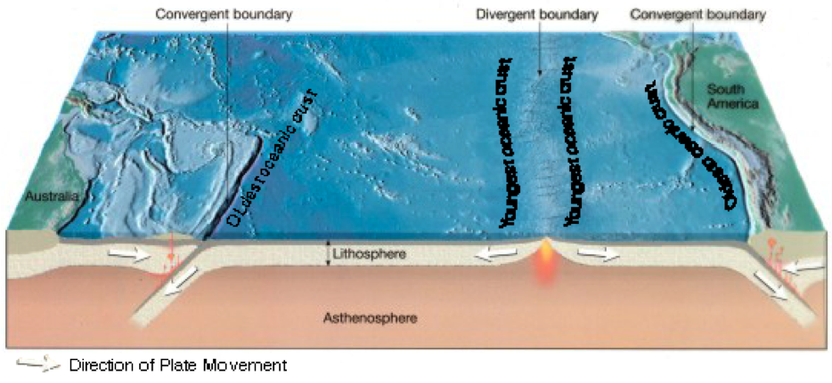

Figure 11 — Ages of Ocean Floor Basalts

*Source:* http://www.google.com/search?q=divergent+and+convergent+plate+boundaries+on+a+map&safe

Since new oceanic crust is made at divergent boundaries (mid-ocean ridges), the ocean floor basalts on the ridges must be very young. As new crust is continually being made at these ridges, the age of the ocean floor basalts must increase with distance from the ridges. Their ages must also increase symmetrically on either side of the ridges. Basalt that is (say) 100km from the eastern side of a ridge must be the same ages as basalt that is 100km from the western side.

Oceanic crust is continually being destroyed at destructive plate boundaries (subduction zones) so no that ocean floor basalts are very old. The oldest ocean floor basalts are only about 200 million years old, whereas the oldest known continental crust rocks are about 3, 800 million years old.

Due to plate movement, oceanic crust is generally much younger than continental crust.

## Earthquakes and Volcanoes

Figure 12 shows that Earthquakes and volcanic activity are generally concentrated along the Earth’s plate boundaries.

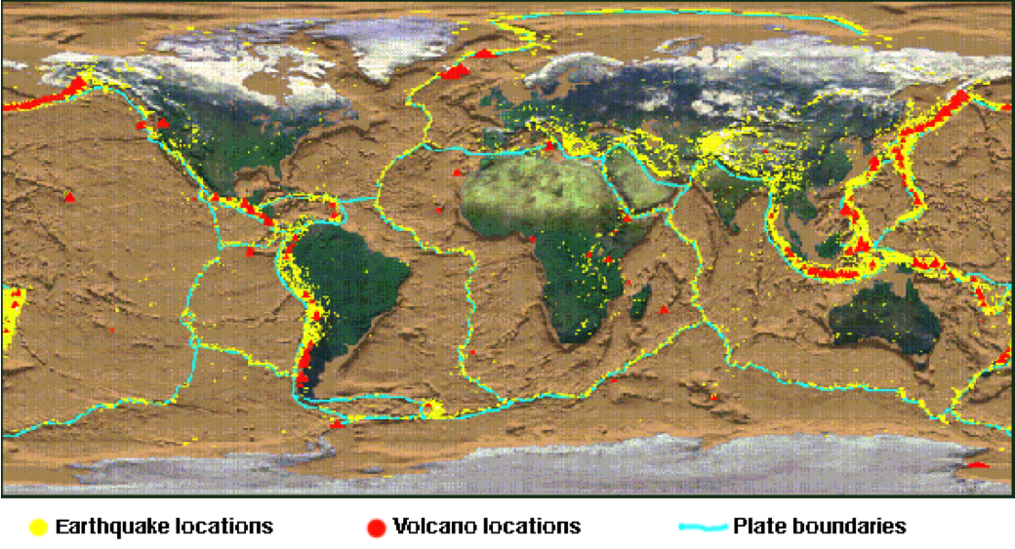

Figure 12 — Worldwide Distribution of Earthquakes, Volcanoes, and Plate Boundaries

*Source:* Adapted from http://www.maine.gov/dacf/mgs/hazards/tsunamis/index.shtml

Volcanoes away from plate boundaries, such as the Hawaiian Islands, occur above hot spots in the mantle.

Earthquakes away from plate boundaries are weaker than those that are actually on the boundaries. They tend to occur because all the Earth’s plates are continually moving and exerting forces on each other.

### Movement of the Plates

Heat energy and convection currents are largely responsible for the movement of tectonic plates

In the late 1950s Professor Harry Hess from Princeton University proposed his theory of sea floor spreading. He proposed that upwelling of mantle material along the mid-ocean ridge system created new sea floor. The convection currents in the mantle material carry the sea floor in a conveyor belt fashion to the deep-ocean trenches, where the sea floor descends into the mantle. Thus, the addition of new oceanic crust forces plates away from each other, thereby separating and moving the continents.

The primary heat source driving the convection currents is thought to be from heat being generated by decaying radioactive elements within Earth and/or heat left over from the formation of the planet.

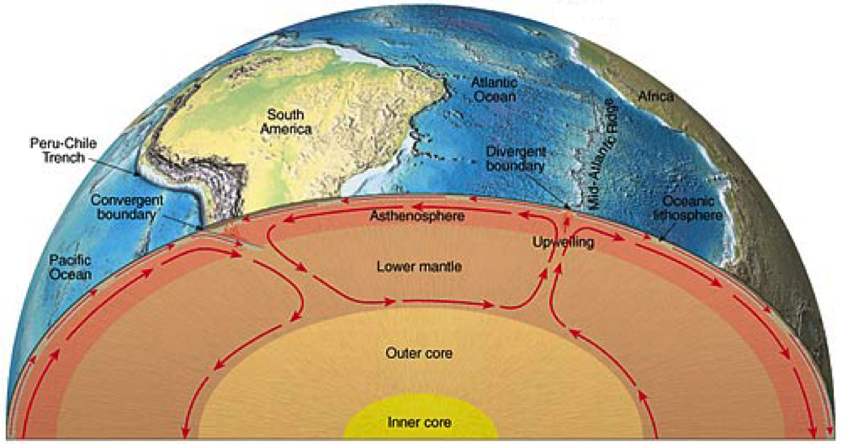

Figure 13 — Convection Currents Moving the Earth's Plates

*Source:* Adapted from http://dn.redwoods.edu/coursenotes/renner/geo_images/plate_tectonics/mantle_convection.jpg

As oceanic crust moves away from the mid-oceanic ridge the crustal material cools, increasing its density. At the same time oceanic sediments accumulate on top of the crust. Eventually this dense crust subducts into the partially molten upper mantle known as the asthenosphere at areas called subduction zones. This cool and dense subducted crust sets up a downward moving convection current, which then acts to drag the dense oceanic crust down further into the mantle. These currents set up convection cells within the upper mantle that contribute to driving the plates over the asthenosphere.

Figure 13 shows how convection currents in the asthenosphere move the rocky continents around. Up‐welling moves the continents apart and spreads the ocean floor, whilst subduction causes   continents to crumple and form mountains.  Stress release from these movements results in earthquakes, volcanoes, landslides and tsunamis.

## Plate Tectonics and Australia Though Time

Both figure 1 and figure 12 show that at present there are no plate boundaries on or very close to the Australian continent. Australia's continental crust has been far distant from constructive and destructive plate boundaries and has escaped strong Earth forces in recent geological history, accounting for its relatively uniform topography when compared with some other continents. Figure 12 also shows that there are no active volcanoes in Australia, but small earthquakes (less than 7 on the Richter scale) do occur. They are due to friction caused by movement of the continent as it is carried along on the Indo-Australian Plate. The comparatively recent (starting 33 million years ago) volcanic activity that occurred along the eastern seaboard as well as in western Victoria and the southeast of South Australia was associated with mantle hotspots, like the Hawaiian Islands, rather than with plate boundaries.

Australia has not always been an island continent with its present boundaries. The oldest rocks in Australia are found in Western Australia, and they were probably part of another continental landmass when they were originally formed. Australia became an island continent about 34 million years ago when it finally broke from Antarctica.

We have seen that the continents have not always occupied their present positions on the Earth’s surface. Plate boundaries have also moved, increasing the complexity of continental wandering.

Throughout the history of the Earth landmasses have been continually in motion. At different times they have all collected together to form supercontinents, which have eventually separated into smaller landmasses. Rodinia was a [supercontinent](http://en.wikipedia.org/wiki/Supercontinent) containing most or all of the [Earth](http://en.wikipedia.org/wiki/Earth)'s landmass, which existed between 1.1 billion and 750 million years ago. The most recent supercontinent, Pangaea, formed approximately 300 million years ago and began to break apart about 200 million years ago. Figure 14 shows how today’s continental landmasses combined to form Pangaea. The supercontinent split first into two continents: a northern continent of Laurasia and a southern continent of Gondwana. These two large continents eventually divided to form the landmasses and oceans we know today.

Figure 14 — The Most Recent Supercontinent — Pangaea

*Source:* http://volcano.oregonstate.edu/vwdocs/vwlessons/lessons/Pangea/Pangea4.html

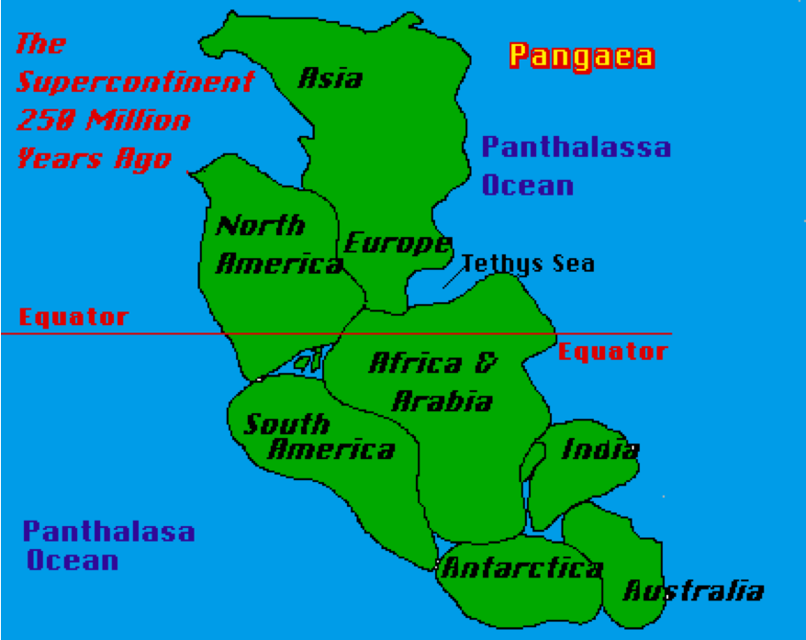

The landmass that now forms continental Australia grew from west to east. Rocks more than 2,500 million years old mostly occur in the west, rocks between 2, 500 and 540 million years old occur in the centre in and the youngest rocks are found in the east. The Pilbara and Yilgarn blocks of Western Australia are the most extensive exposures of ancient rocks in Australia. Some of the oldest examples of modern plate tectonics are preserved in the western part of the Pilbara block. The igneous rocks of this region have distinctive characteristics that are very similar to those found in modern island arc environments.

Compared with other periods of time, Australia was relatively quiescent between 1300 Ma and 700 Ma, possibly because the landmass was largely in a long way from any plate boundaries during this time.

The Mount Lofty and Flinders Ranges in South Australia and the Great Dividing Range in New South Wales and Queensland are the remains of fold mountain ranges that were formed, possibly by subduction of an oceanic plate under a continental plate hundreds of millions of years ago.

The Adelaide Geosyncline stretches from the northern parts of the [Flinders Ranges](http://austhrutime.com/flinders_ranges.htm) to [Kangaroo Island](http://austhrutime.com/kangaroo_island.htm). Sediments were deposited in a depression that is believed to have formed as the crust was stretched during the breakup of the supercontinent of [Rodinia](http://austhrutime.com/rodinia.htm). It was in the form of an arc about 1000 km long and several hundred km wide. At their deepest the sediments that eventually formed limestones, shales and sandstones, as well as some volcanics, reached up to 24,000m thick. The nature of the rocks suggests that most of the sediments were deposited marine environment. At the time of their deposition, from about 870 million years ago to about 500 million years ago the area was the ocean next to the east coast of the existing continent. Similar rocks are found on the west cost of North America, leading to the suggestion that before the break-up of Rodinia, North America was connected to eastern [Gondwana](http://austhrutime.com/gondwana_timeline.htm).

About 500 million years ago, the sediments deposited in the Adelaide Geosyncline were folded and uplifted to become a high mountain range. The [Flinders Ranges](http://austhrutime.com/flinders_ranges.htm) and the [Mt Lofty Ranges](http://austhrutime.com/mt_lofty_ranges.htm) are highly eroded remains of this mountain range. There were also a number of igneous intrusions, such as the granites of Victor Harbor, and in the eastern Mt Lofty Ranges. The earliest subduction phase was to the east, and the folding and uplifting may have been the result of collision with an island arc complex on the Pacific Plate with the margin of Australia.

The Tasman Geosyncline was a linear trough in the Earth’s crust that formed a broad belt to the east of the Flinders and Mt. Lofty Ranges and extending from Tasmania in the south to Cape York in the north. Sediments that produced rocks formed about 400 million years ago were deposited in this trough. Several folding and uplifting events occurred during the existence of the Tasman Geosyncline, and these episodes folded and crumpled the rock strata to form what has eventually become the Great Dividing Range.

Rocks younger than 251 million years are essentially flat-lying above the folded layers produced in the Tasman Geosyncline, thus providing evidence for the stability of eastern Australia in the past 251 million years.

As a general rule, we can say that folded and faulted rocks, mountain ranges and some volcanic activity indicate the locations of former plate boundaries, while flat lying rocks were formed a long way from any plate boundaries.

**References:**

<http://www.pbs.org/wgbh/aso/databank/entries/bowege.html>

http://en.wikipedia.org/wiki/Continental_drift

<http://austhrutime.com/adelaide_geosyncline.htm>

http://austhrutime.com/delamerian_orogeny.htm

<http://www.resources.nsw.gov.au/geological/overview/statewide>

<http://www.earthsciencewa.com.au/course/view.php?id=16>

Wikepedia