Earth Hazards: Can earthquakes be predicted?
A NOTE FOR TEACHERS:
This Investigation would be best conducted following some initial teaching and learning about earthquakes in the Earth Hazards topic.
Students are asked to design, implement and report the outcome of an investigation to test a particular hypothesis of their choice, using the QuakeCaster apparatus. This valuable teaching and learning tool was designed by the United States Geological Survey (USGS). Information about how to build the apparatus (approximate cost $500) and various suggestions for using it are available on the USGS website: https://pubs.er.usgs.gov/publication/ofr20111158
Teachers who are members of the Geoscience Pathways Project (GPP) are invited to borrow the apparatus by contacting the GPP Coordinator: lenaltman9@gmail.com (Membership of the GPP is free)

Earth Hazards: Can Earthquakes be predicted?
In this task you will use the QuakeCaster apparatus (pictured below) to design, implement and report your findings about a particular hypothesis of your choice.
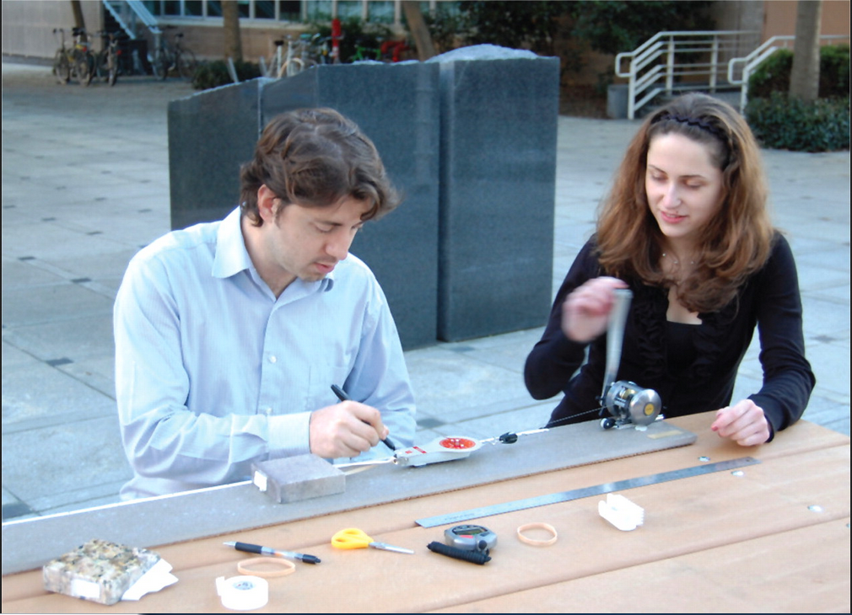
It is often reported in the media that an earthquake in a particular location, or along a particular fault is ‘overdue’. The implication of ‘overdue’ is that earthquakes are ‘time dependent’. If previous earthquakes were 20 years apart (for example), and no earthquake has occurred over the recent 25 years, we might be tempted to use the term ‘overdue’.
Time dependency is one of several hypotheses that you might choose to investigate,Others include:
* stress dependency
* strike slip dependency
* small ‘foreshocks’ precede bigger earthquakes.
Part B: Report
Your report should include:
- Relevant earth and environmental science concepts or background
- A conclusion that answers your question
- In text referencing and a reference list using Harvard referencing.
Assessment Conditions:
Some class time is provided for research and support. Students have 2 weeks to complete the task. Students may submit one draft for feedback.
Word Count: maximum of 1000 words or 6 minutes for an oral presentation.
Assessment Design Criteria
Investigation, Analysis and Evaluation: IA 1,2,3,4 Knowledge and Application: KA 2, 4

Performance Standards for Stage 1 Earth and Environmental Science
- | Investigation, Analysis, and Evaluation | Knowledge and Application
A | Designs a logical, coherent, and detailed earth and environmental science investigation.  Obtains, records, and represents data, using appropriate conventions and formats accurately and highly effectively.  Systematically analyses and interprets data and evidence to formulate logical conclusions with detailed justification.  Critically and logically evaluates procedures and their effect on data. | Demonstrates deep and broad knowledge and understanding of a range of earth and environmental science concepts.  Develops and applies earth and environmental science concepts highly effectively in new and familiar contexts.  Critically explores and understands in depth the interaction between science and society.  Communicates knowledge and understanding of earth and environmental science coherently, with highly effective use of appropriate terms, conventions, and representations.
B | Designs a well-considered and clear earth and environmental science investigation.  Obtains, records, and represents data, using appropriate conventions and formats mostly accurately and effectively.  Logically analyses and interprets data and evidence to formulate suitable conclusions with reasonable justification.  Logically evaluates procedures and their effect on data. | Demonstrates some depth and breadth of knowledge and understanding of a range of earth and environmental science concepts.  Develops and applies earth and environmental science concepts mostly effectively in new and familiar contexts.  Logically explores and understands in some depth the interaction between science and society.  Communicates knowledge and understanding of earth and environmental science mostly coherently, with effective use of appropriate terms, conventions, and representations.
C | Designs a considered and generally clear earth and environmental science investigation.  Obtains, records, and represents data, using generally appropriate conventions and formats with some errors but generally accurately and effectively.  Undertakes some analysis and interpretation of data and evidence to formulate generally appropriate conclusions with some justification.  Evaluates procedures and some of their effect on data. | Demonstrates knowledge and understanding of a general range of earth and environmental science concepts.  Develops and applies earth and environmental science concepts generally effectively in new or familiar contexts.  Explores and understands aspects of the interaction between science and society.  Communicates knowledge and understanding of earth and environmental science generally effectively, using some appropriate terms, conventions, and representations.
D | Prepares the outline of an earth and environmental science investigation.  Obtains, records, and represents data, using conventions and formats inconsistently, with occasional accuracy and effectiveness.  Describes data and undertakes some basic interpretation to formulate a basic conclusion.  Attempts to evaluate procedures or suggest an effect on data. | Demonstrates some basic knowledge and partial understanding of earth and environmental science concepts.  Develops and applies some earth and environmental science concepts in familiar contexts.  Partially explores and recognises aspects of the interaction between science and society.  Communicates basic earth and environmental science information, using some appropriate terms, conventions, and/or representations.
E | Identifies a simple procedure for an earth and environmental science investigation.  Attempts to record and represent some data, with limited accuracy or effectiveness.  Attempts to describe results and/or interpret data to formulate a basic conclusion.  Acknowledges that procedures affect data. | Demonstrates limited recognition and awareness of earth and environmental science concepts.  Attempts to develop and apply earth and environmental science concepts in familiar contexts.  Attempts to explore and identify an aspect of the interaction between science and society.  Attempts to communicate information about earth and environmental science.

