SACE Stage 2 Earth and Environmental Science
Earth Systems Study (external assessment)

Students investigate factors that have affected the decline of two endangered plant species
and through practical activity, identify the best methods of assisting the survival of these species through the strategy of developing a ‘seed orchard’ on school grounds.

A NOTE FOR TEACHERS:

This Investigation is one option to be offered at Marden Senior College under the auspices of the Stewardship of Endemic Endangered Species (SEEDS) project. This work is in association with the Adelaide Botanic Gardens. The project at Marden has also been supported by a small grant from the NRM Board, and is planned to be implemented in part as an Earth Systems Study for the Stage 2 Earth and Environmental Science class in 2018.

The whole class will participate in the establishment of two raised beds, an automatic irrigation system and the planting of seedlings that have been raised at the Botanic Gardens.

Individual students may choose to investigate a particular factor (or factors) affecting the propagation of these endangered species, formulate an appropriate research question and then design, plan, implement and prepare a scientific report of their findings. A list of some possible investigable factors will be provided to students, but their choice may be other than those on this list. Students may also elect to design their own Earth Systems Study, unrelated to the SEEDS project, however in all cases students must submit one draft proposal for teacher feedback prior to undertaking their investigation.

The seed produced (in the future) will be used to propagate tube-stock for specific pre-existing revegetation programs in regional parts of South Australia.

Swainsona behriana - is a perennial herb about 15cms high. It is endangered and regionally extinct in some parts of the state. There is a conservation project in the Gawler Woodlands that we will be growing for.
Brachyscome parvula - or ‘coastal daisy,’ is from coastal areas South East of Adelaide and is an annual perennial herb about 40 cm high. The conservation project matched for this species is the Friends of Cromer Landcare group in the Adelaide Hills.

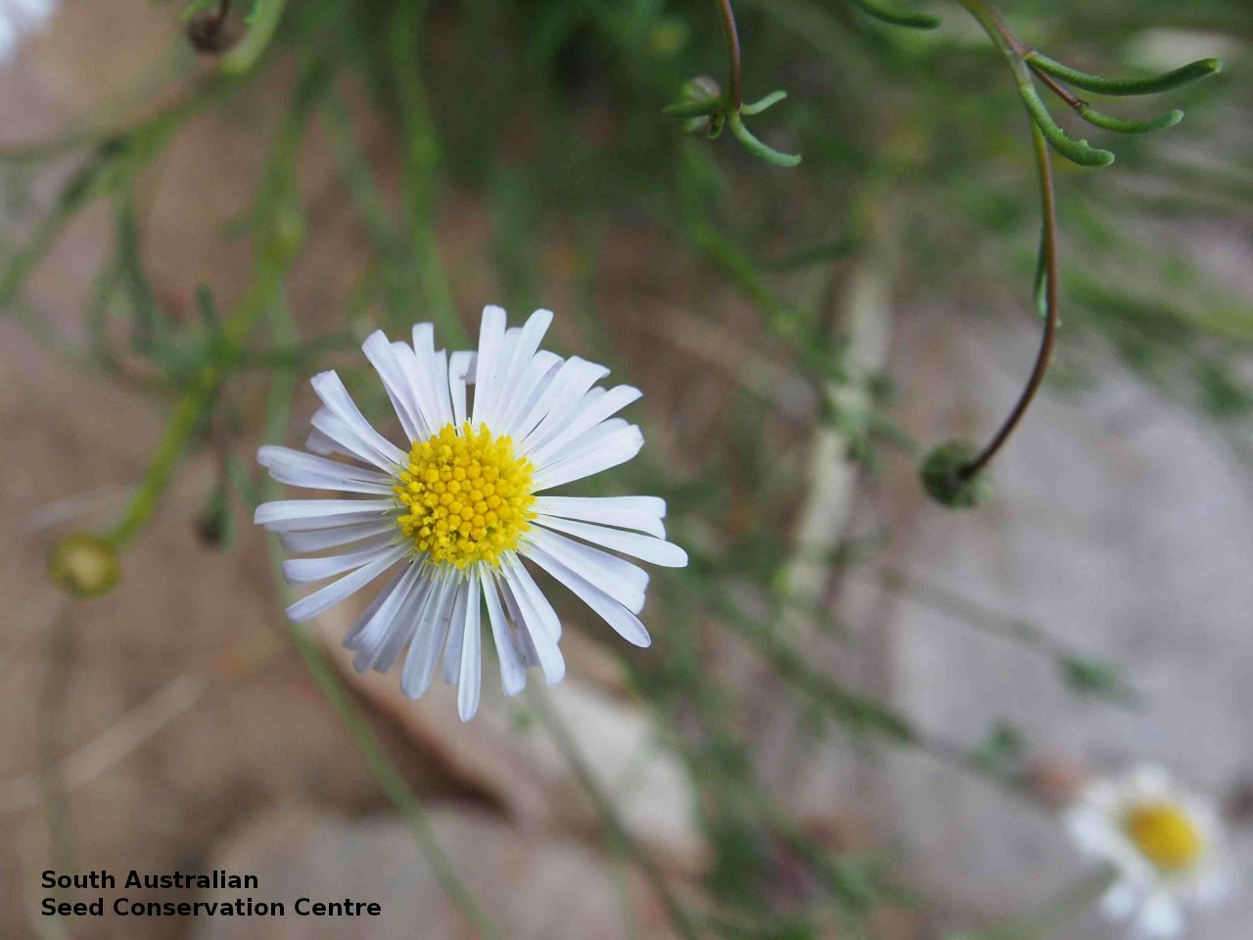
Brachyscome parvula

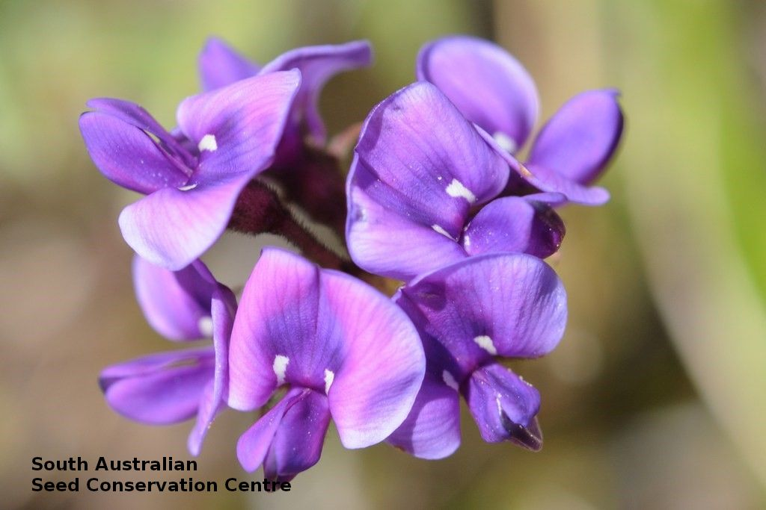

Swainsona behriana

Assessment Type 3 - Earth Systems Study

This Study will be externally assessed. It represents 30% of the final marks in this subject.

Purpose
This assessment allows you to develop and demonstrate your field observation skills and to communicate your knowledge through an Earth Systems Study report. You will undertake an investigation into the SEEDS project, or another particular local environmental issue, concern, initiative, or successful undertaking that can be linked to topics studied in Stage 2 Earth and Environmental Science.

You will develop a research question, then design, plan, undertake, and report on a field-based extended investigation to answer your question. The investigation must include collection and analysis of both primary and secondary data. You will need to be able to analyse the information gathered in terms of the interactions of two or more Earth systems.

The Stewardship of Endemic Endangered Species (SEEDS) project.
Marden Senior College has won the opportunity to participate in this project, in association with the Adelaide Botanic Gardens. Our task is to work towards the development of a ‘seed orchard’, to protect the two endangered species shown in the next page.

You may choose to design your study as part of this SEEDS project, or alternatively design an unrelated study that meets the requirements of this assessment type. If you choose the latter, your research must require fieldwork into another particular local environmental issue, concern, initiative or successful undertaking that can be linked to topics in Stage 2 Earth and Environmental Science.

Whichever option you choose, your investigation must include collection and analysis of both primary and secondary data, and you must analyse the information gathered in terms of the interactions of two or more Earth systems.

Some possible investigation questions for the SEEDS project, (examples only)

* what has caused these species to become endangered?
* which plants are the natural ‘companion plants’ at the natural site?
* how does the soil at the site compare with the soil in the garden beds?
* how does the soil bacteria compare, in the two situations?
* which insects pollinate these species in the wild?
* is there a difference between rainwater and tap water, for seedling growth?

You may choose any other appropriate investigation question, beyond the examples above.

Description of assessment

Proposal (IAE1) – Individually

You will design an investigation proposal then trial your methods to assist the design of your procedure. You may wish to collect your data independently or during a fieldwork excursion.

One draft of the proposal should be submitted for teacher feedback and approval. You may modify your proposal in response to this feedback before you undertake your investigation.

Your modified proposal must be submitted with your report for assessment.

The proposal should include:
- a statement of an investigable question or hypothesis
- a rationale for and an outline of the proposed research approach and method
- a list of equipment required
- the procedure to be followed
- the type of data that will be collected
- a risk assessment that addresses safety, ethical, and legal considerations.

Report – Individually

The report should use scientific terminology and include:

- an introduction to identify the purpose, and relevant background or previous research into the topic (KA1, 4)
- appropriate representation of data, e.g. tables, graphs, maps, charts, photographs, or other illustrations (IAE2)
- analysis of the information gathered in terms of the interactions of two or more Earth systems (IAE3)
- evaluation of procedures and results to identify limitations of, and improvements to, the investigation (IAE4)
- a conclusion, which includes predictions or advice based on findings (IAE3)
- citations and referencing (KA4)

Assessment conditions

The combined word count for the proposal and the report should be a maximum of 2000 words, if written, or the equivalent in multimodal form.

Your work will be assessed using the performance standards for Stage 2 Earth and Environmental Science on the next page:

Performance Standards for Stage 2 Earth and Environmental Science
- | Investigation, Analysis, and Evaluation | Knowledge and Application
A | Designs a logical, coherent, and detailed earth and environmental science investigation.  Obtains, records, and represents data, using appropriate conventions and formats accurately and highly effectively.  Systematically analyses and interprets data and evidence to formulate logical conclusions with detailed justification.  Critically and logically evaluates procedures and their effect on data. | Demonstrates deep and broad knowledge and understanding of a range of earth and environmental science concepts.  Develops and applies earth and environmental science concepts highly effectively in new and familiar contexts.  Critically explores and understands in depth the interaction between science and society.  Communicates knowledge and understanding of earth and environmental science coherently, with highly effective use of appropriate terms, conventions, and representations.
B | Designs a well-considered and clear earth and environmental science investigation.  Obtains, records, and represents data, using appropriate conventions and formats mostly accurately and effectively.  Logically analyses and interprets data and evidence to formulate suitable conclusions with reasonable justification.  Logically evaluates procedures and their effect on data. | Demonstrates some depth and breadth of knowledge and understanding of a range of earth and environmental science concepts.  Develops and applies earth and environmental science concepts mostly effectively in new and familiar contexts.  Logically explores and understands in some depth the interaction between science and society.  Communicates knowledge and understanding of earth and environmental science mostly coherently, with effective use of appropriate terms, conventions, and representations.
C | Designs a considered and generally clear earth and environmental science investigation.  Obtains, records, and represents data, using generally appropriate conventions and formats with some errors, but generally accurately and effectively.  Undertakes some analysis and interpretation of data and evidence to formulate generally appropriate conclusions with some justification.  Evaluates procedures and some of their effect on data. | Demonstrates knowledge and understanding of a general range of earth and environmental science concepts.  Develops and applies earth and environmental science concepts generally effectively in new or familiar contexts.  Explores and understands aspects of the interaction between science and society.  Communicates knowledge and understanding of earth and environmental science generally effectively, using some appropriate terms, conventions, and representations.
D | Prepares the outline of an earth and environmental science investigation.  Obtains, records, and represents data, using conventions and formats inconsistently, with occasional accuracy and effectiveness.  Describes data and undertakes some basic interpretation to formulate a basic conclusion.  Attempts to evaluate procedures or suggest an effect on data. | Demonstrates some basic knowledge and partial understanding of earth and environmental science concepts.  Develops and applies some earth and environmental science concepts in familiar contexts.  Partially explores and recognises aspects of the interaction between science and society.  Communicates basic earth and environmental science information, using some appropriate terms, conventions, and/or representations.
E | Identifies a simple procedure for an earth and environmental science investigation.  Attempts to record and represent some data, with limited accuracy or effectiveness.  Attempts to describe results and/or interpret data to formulate a basic conclusion.  Acknowledges that procedures affect data. | Demonstrates limited recognition and awareness of earth and environmental science concepts.  Attempts to develop and apply earth and environmental science concepts in familiar contexts.  Attempts to explore and identify an aspect of the interaction between science and society.  Attempts to communicate information about earth and environmental science.

