SACE Stage 2 Earth and Environmental Science

Field Investigation 1: Sea level change at Hallett Cove

A NOTE FOR TEACHERS:

This field investigation might be either formative or summative. It has been designed to give students opportunity to develop the *Scientific Inquiry Skills* needed for the externally assessed Earth Systems Study, including the skills needed for field data collection, analysis and report writing. It might also stimulate ideas and class discussion for planning an earth systems study for external assessment.

Ideally, it would be undertaken following some early lessons in the recommended first topic, **Earth Systems.** It provides a first opportunity to consider the interaction between Earth systems in a local field setting.

There are other good reasons to provide a field investigation as early as possible in your teaching program, including:

• to demonstrate the importance of field work in EES

• to get students out of the classroom at the ideal time (summer)

Lessons/class research/ discussion prior to this investigation might include:

• An introduction to the *Geological Time Scale*, such as by using the simplified version provided on the next page,

• Contemporary, global sea level change.

For example how data is collected and presented, possible causes and predicted effects. (<https://climate.nasa.gov/climate_resources/125/> )

Reference to the most recent measure of annual global sea level rise of 3.6 mm, (<https://climate.nasa.gov/vital-signs/sea-level/> ). This field investigation could be used to compare this current rate to the historical rate over the past 3 million years. (See assumptions)

• An overview of sea level change over a range of longer time scales.

For example how 10, 000 years ago the nearest shoreline to the Adelaide plains was south of Kangaroo island. At that time the Kaurna people could walk across what is now Spencer’s Gulf to Yorke Peninsula. Similarly, the position now occupied by the Great Barrier Reef was dry land, well above sea level at that same time. (<http://www.abc.net.au/catalyst/stories/4045476.htm> )

•



SACE Stage 2 Earth and Environmental Science

Field Investigation 1: Sea level change at Hallett Cove

*Interaction between the* ***hydrosphere*** *and* ***geosphere*** *during sea level change cause the changing position of shorelines. These changing shorelines inevitably cause change to the local environment and result in changes to the* ***biosphere*** *over time.*

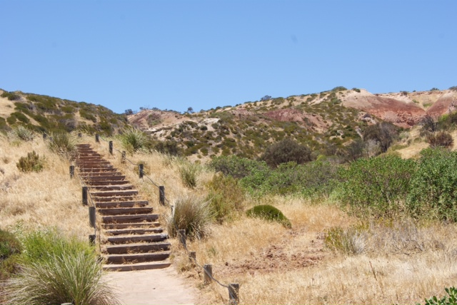

In this investigation you will work collaboratively to deconstruct, design, implement and then individually report on the results of a method to estimate the position of the shoreline across the Adelaide plains, as it might have been when the *Hallett Cove Sandstone* was deposited, approximately 3 Ma. This apparent rise in sea level is clear and measurable at Hallett Cove. As part of this investigation you will need to design a method to collect field data appropriate to calculate the rise (in metres). You might pose a *question* or set a *hypothesis*, to guide your work.

For an overview of the geology of Hallett Cove and the location of outcrops of the *Hallett Cove Sandstone* you might download a brochure from the Geological Society of Australia:

<https://www.gsa.org.au/Public/Divisions/South_Australia/SA_Geology_Field_Brochures/Public/Divisions/SA_Subpages/SA_Geology_Field_Brochures.aspx?hkey=ffe847f7-5720-44f3-85c5-dee44fd74055>

**To collect field data you might use equipment including:**

• a hand-held GPS unit (eg Garmin 60), or

• a smart-phone app (such as ‘Clino’), or

• a compass/clinometer (such as a ‘Suunto’ sighting compass),

• a measuring chain

• a camera

**To make appropriate calculations and to prepare your report you might need:**

• some basic right angle triangle trigonometry,

• a topographic map of the Adelaide plains,

• graphical presentation software/skills

**REPORT**

Your report should be no more than 1500 words in length, (or 10 minutes if an oral presentation or in multimodal form) and should include:

* An introduction with relevant earth and environmental concepts and either a hypothesis and variables or an investigable question,
* deconstruction of the problem* (attached summary),
* materials/apparatus*,
* method/procedure outlining the steps taken*,
* identification and management of safety and/or ethical risks*,
* results*,
* analysis of results, identifying trends, and linking results to concepts,
* evaluation of procedures and data, and identifying sources of uncertainty
* conclusion, with justification.      

                                                                                     

* The five blue asterisked sections (deconstruction, materials/apparatus, method/procedure, ethical risks, and results) are excluded from the word count.

**ASSESSMENT**

This is one of eight required assessments, including the externally assessed Earth Systems Study (30%). It will provide *10% of your final school assessment mark.*

Your work will be assessed using the performance standards for Stage 2 Earth and Environmental Science that are highlighted on the next page:

|  | Investigation, Analysis, and Evaluation | Knowledge and Application |
| --- | --- | --- |
| **A** | Designs a logical, coherent, and detailed earth and environmental science investigation.  Obtains, records, and represents data, using appropriate conventions and formats accurately and highly effectively.  Systematically analyses and interprets data and evidence to formulate logical conclusions with detailed justification.  Critically and logically evaluates procedures and their effect on data. | Demonstrates deep and broad knowledge and understanding of a range of earth and environmental science concepts.  Develops and applies earth and environmental science concepts highly effectively in new and familiar contexts.  Critically explores and understands in depth the interaction between science and society.  Communicates knowledge and understanding of earth and environmental science coherently, with highly effective use of appropriate terms, conventions, and representations. |
| **B** | Designs a well-considered and clear earth and environmental science investigation.  Obtains, records, and represents data, using appropriate conventions and formats mostly accurately and effectively.  Logically analyses and interprets data and evidence to formulate suitable conclusions with reasonable justification.  Logically evaluates procedures and their effect on data. | Demonstrates some depth and breadth of knowledge and understanding of a range of earth and environmental science concepts.  Develops and applies earth and environmental science concepts mostly effectively in new and familiar contexts.  Logically explores and understands in some depth the interaction between science and society.  Communicates knowledge and understanding of earth and environmental science mostly coherently, with effective use of appropriate terms, conventions, and representations. |
| **C** | Designs a considered and generally clear earth and environmental science investigation.  Obtains, records, and represents data, using generally appropriate conventions and formats with some errors, but generally accurately and effectively.  Undertakes some analysis and interpretation of data and evidence to formulate generally appropriate conclusions with some justification.  Evaluates procedures and some of their effect on data. | Demonstrates knowledge and understanding of a general range of earth and environmental science concepts.  Develops and applies earth and environmental science concepts generally effectively in new or familiar contexts.  Explores and understands aspects of the interaction between science and society.  Communicates knowledge and understanding of earth and environmental science generally effectively, using some appropriate terms, conventions, and representations. |
| **D** | Prepares the outline of an earth and environmental science investigation.  Obtains, records, and represents data, using conventions and formats inconsistently, with occasional accuracy and effectiveness.  Describes data and undertakes some basic interpretation to formulate a basic conclusion.  Attempts to evaluate procedures or suggest an effect on data. | Demonstrates some basic knowledge and partial understanding of earth and environmental science concepts.  Develops and applies some earth and environmental science concepts in familiar contexts.  Partially explores and recognises aspects of the interaction between science and society.  Communicates basic earth and environmental science information, using some appropriate terms, conventions, and/or representations. |
| **E** | Identifies a simple procedure for an earth and environmental science investigation.  Attempts to record and represent some data, with limited accuracy or effectiveness.  Attempts to describe results and/or interpret data to formulate a basic conclusion.  Acknowledges that procedures affect data. | Demonstrates limited recognition and awareness of earth and environmental science concepts.  Attempts to develop and apply earth and environmental science concepts in familiar contexts.  Attempts to explore and identify an aspect of the interaction between science and society.  Attempts to communicate information about earth and environmental science. |