# Student Worksheet

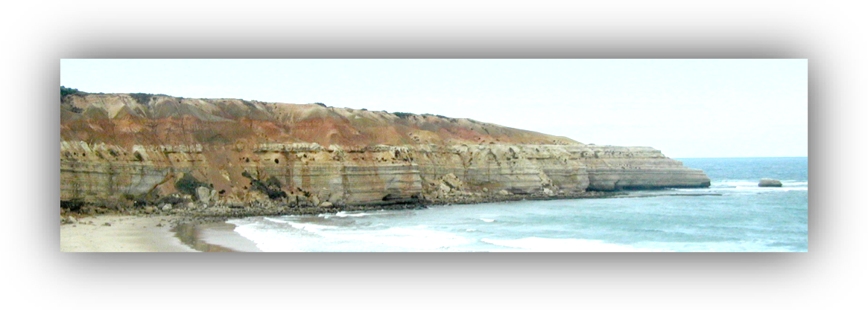

## Name _______________________________________ Date ____________

The maps below show the location of our excursion and the route we will be taking to get there.

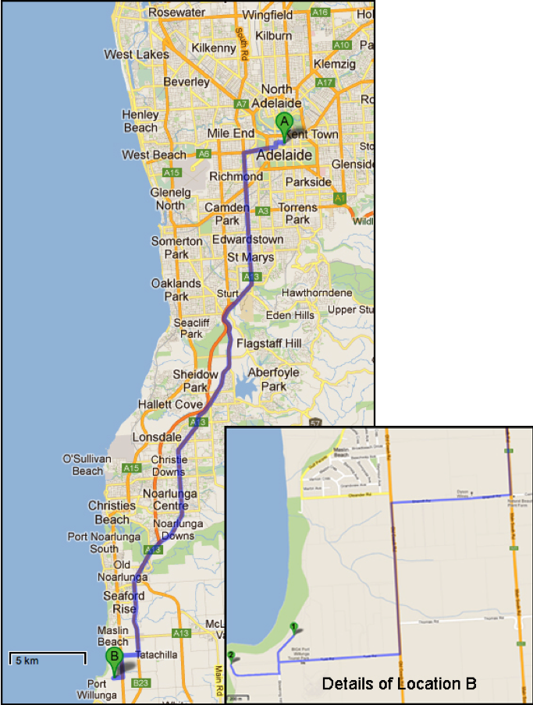

Figure 1 — Where we are Going

## Important Guidelines for Students

Wear a hat, sturdy shoes and apply sunscreen even during winter months.

Carry drinking water

Carry sufficient food. There is nowhere to buy food until you get to the end of the excursion.

Safety First! Keep to the defined walking trail except when on the beaches

Avoid overhanging rocks, which could potentially fall.

Stay well back from the tops of cliffs.

Weather conditions can change quickly. Ensure that you wear and bring appropriate clothing.

## Aim and Outline of Excursion

The principal aim of this excursion is to study a sequence of sedimentary rock layers that were deposited in the Willung Basin about 42 million years ago when the sea covered the area that now forms the Adelaide Plains; as well as several areas along the coastline south of Adelaide.

Since these rocks are tilted to the south at about 5°, each layer comes down to beach level somewhere along either Maslin Bay or Port Willunga beach.

We will therefore study the older (lower) rocks in the sequence from the steps down to Maslin Bay and then walk along Port Willunga beach to see the younger (upper) rocks.

We cannot walk around Blanche Point so we have to walk up the steps from Maslin Beach and return to the bus.

Our walk and our study locations are shown in the satellite image below.

## How to Use this Booklet

This booklet contains information about the geological features we will see on the excursion and asks you questions about them. To answer some of the questions, you need to write a sentence or two, while for other you need to draw diagrams.

All the left hand pages in the booklet have been left blank for your use. If you cannot fit a written answer or a diagram into the space provided after the question, you can use the blank page opposite the question. You can also use these blank sheets to add any of your own ideas and observations.

Figure 2 — Our Walk, mainly along the Beach

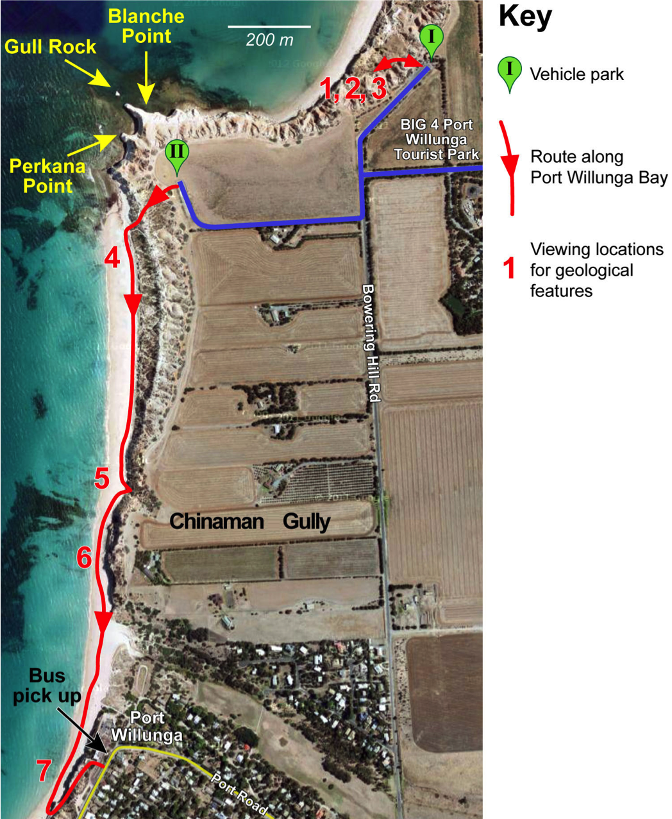

## Stop I — Maslin Bay Car Park

### 1 Structure of the Willunga Basin

Look inland from the car park. You can see:

* The Willunga Fault, which is the edge of the older rocks of the Mt. Lofty Ranges and forms the rim of the basin containing the sedimentary rocks we will be studying.
* these more recent, Neogene, sedimentary rocks on which we are now standing.

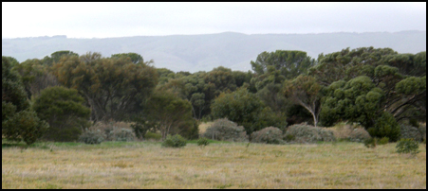 Label the photograph below to show these features.

### 2 Tilted and horizontal layers

Walk along the path to the beach until you have a good view of the cliffs surrounding the southern end of Maslin Bay. The view you see is shown in the photograph below.

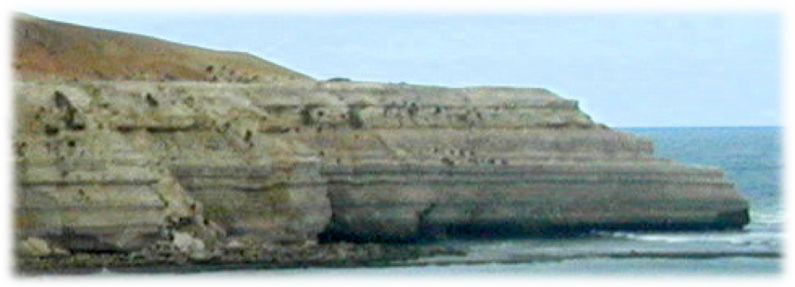

Figure 3 — Cliffs at the Southern end of Maslin Bay

outhern end of Maslin Bay

a. Label the photograph to show:

(i) the older, Palaeogene, rocks that are tilted to the south at about 5°

(ii) the horizontal Pliocene (middle Neogene) layer of Hallett Cove Sandstone

(iii) the younger sediments that have been eroded from the Mt. Lofty Ranges.

b. On the photograph, mark and label evidence that the sea has been eroding the cliffs.

### 3 The Steps down to Maslin Bay

The diagram below gives the names and ages of the rock layers we will see in Maslin Bay and along Port Willunga beach.

Figure 4 — The Rock Layers we will see

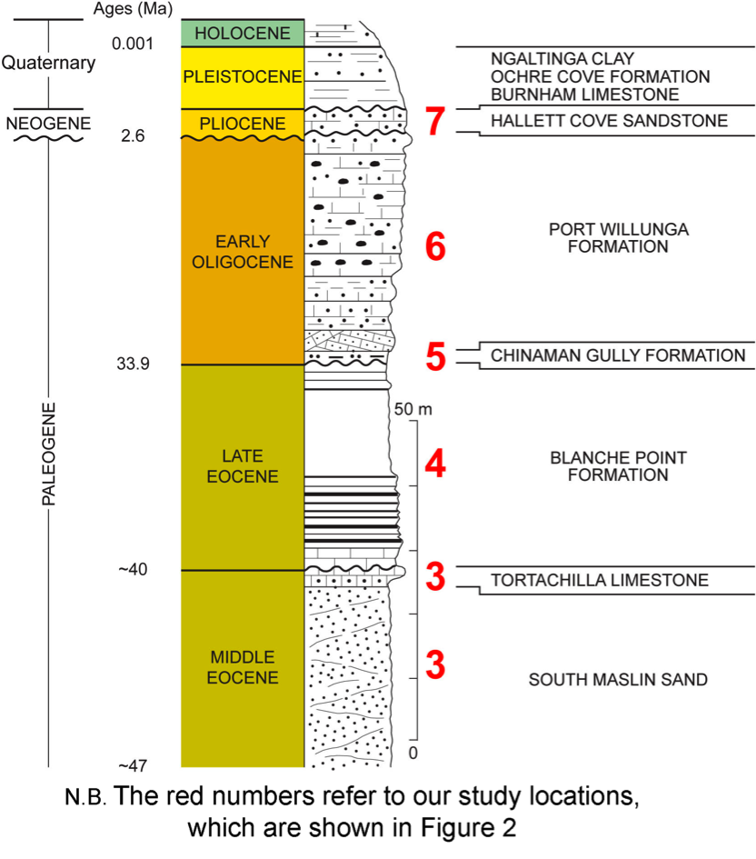

We will go part of the way down the steps to Maslin Bay.

a. *Cross out the incorrect words in the following sentence:*

As we go down the steps, we will pass from (older/younger) rocks to (older/younger) rocks.

b. At the bend in the steps, we will see the two oldest of the layers shown in Figure 4. Name these two rock types.

______________________________________________________________________

c. Complete the table below for the two rock layers you have just named.

**ROCKS SEEEN FROM MASLIN BAY STEPS**

|  |  |  |  |  |  |
| --- | --- | --- | --- | --- | --- |
| **NAME OF ROCK LAYER** | **INFORMATION ABOUT THE ROCK** | | | | |
| **COLOUR/S** | **GRAINS CEMENTED TOGETHER?** | **GRAIN SIZE** | **DESCRIPTIONS OF ANY FOSSILS** | **ENVIRONMENT OF FORMATION** |
|  |  |  |  |  |  |
|  |  |  |  |  |  |

d. Is the boundary between the layers sharp, or does it provide evidence of a gradual change in conditions?

___________________________________________________________________________

___________________________________________________________________________

You may collect fossils at this location. Record some information about them in the table on p8.

## Stop Ii — Port Willunga Cliffs Car Park

We will leave the bus here, descend the cliff path and then walk along the beach, studying locations 4 to 7 as we walk along. The bus will pick us up at the end of our walk.

From the Port Willunga beach we will see the following rock layers:

* Blanche Point Formation
* Chinaman Gully Beds
* Port Willunga Beds
* Hallett Cove Sandstone
* Younger sediments

a. Complete the table on the next page for each of these beds.

As we walk along the beach, we will look for other interesting features that may be present.

|  |  |  |  |  |  |
| --- | --- | --- | --- | --- | --- |
| **ROCK LAYER & LOCATION** | **INFORMATION ABOUT THE ROCK** | | | | |
| **COLOUR/S** | **GRAINS CEMENTED TOGETHER?** | **GRAIN SIZE** | **DESCRIPTIONS OF ANY FOSSILS** | **ENVIRONMENT OF FORMATION** |
| **4**  Blanche Point Formation |  |  |  |  |  |
| **5**  Chinaman Gully Formation  *See also question on next page* |  |  |  |  |  |
| **6**  Port Willunga Formation |  |  |  |  |  |
| **7**  Hallett Cove Sandstone |  |  |  |  |  |
| **7**  Younger Sediments |  |  |  |  |  |

## A Dramatic Change

Just after you leave Chinaman Gully, look for the feature shown in Figure 5, which shows another sharp boundary between two rock types.

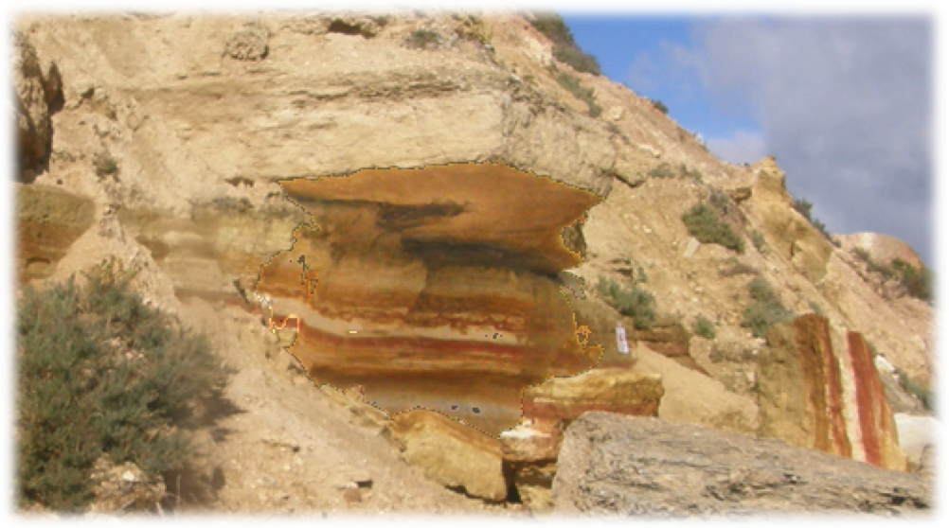

Figure 5 — Another boundary Between Two Rock Types

1 On the above photograph, write the names of the two rock types and draw part of the boundary between them.

Figure 6 shows the same boundary as it was at the end of March 2012.

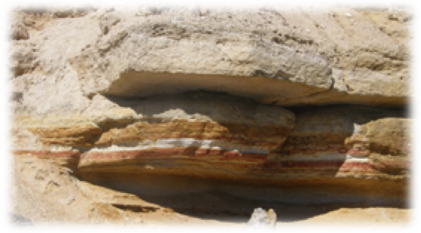

Figure 6 — This Boundary as it Once Was!

2 Describe the changes that have occurred at this boundary.

______________________

______________________

______________________

______________________

3 Suggest a reason, other than the different strengths of the rocks, why the coloured layer has collapsed, but the white layer is still strong.

___________________________________________________________________________

## Special Features of The Rocks

As we walk along the beach, we will see some special features of interest in some of the rocks. Describe and sketch these features as we see them

### A. Fossils

Some of the rock layers contain fossils, such as those shown in the diagram below.

In the table below, identify and sketch any fossils you find, naming the rock layer in which you found them.

|  |  |  |
| --- | --- | --- |
| **NAME OF FOSSIL** | **SKETCH** | **LOCATION & ROCK LAYER WHERE FOUND** |
|  |  |  |

### B. Sedimentary structures, such as ripple marks, cross-bedding or slump structures.

In the table below, identify and sketch any sedimentary structures you see as we walk along the beach, naming the rock layer in which you found them.

|  |  |  |
| --- | --- | --- |
| **NAME OF SEDIMENTARY STRUCTURE** | **SKETCH** | **LOCATION & ROCK LAYER WHERE FOUND** |
|  |  |  |

### C. Biogenic Structures, such as worm burrows.

In the table below, identify and sketch any sedimentary structures you see, naming the rock layer in which you found them.

|  |  |  |
| --- | --- | --- |
| **NAME OF BIOGENIC STRUCTURE** | **SKETCH** | **LOCATION & ROCK LAYER WHERE FOUND** |
|  |  |  |

### D. Tectonic Structures, such as folds and faults.

In the table below identify and sketch any tectonic structures you see, naming the rock layer in which you found them.

|  |  |  |
| --- | --- | --- |
| **NAME OF TECTONIC STRUCTURE** | **SKETCH** | **LOCATION & ROCK LAYER WHERE FOUND** |
|  |  |  |

### E. Evidence of Human Activity (Location 7)

Suggest the original functions of the caves and the jetty.

___________________________________________________________________________

___________________________________________________________________________

___________________________________________________________________________

In the table, below, record and sketch any other evidence of human activity you can see, naming the location in which you found it.

|  |  |  |
| --- | --- | --- |
| **EVIDENCE OF HUMAN ACTIVITY** | **SKETCH** | **LOCATION WHERE FOUND** |
|  |  |  |

### F. The Power of the Sea (Location 7)

Look for evidence that the sea is invading the land at Port Willunga. Enter your findings in the table below.

|  |  |
| --- | --- |
| **EVIDENCE OF INVADING SEA** | **LOCATION WHERE FOUND** |
|  |  |

# Summing Up

## I Points of View

You have described evidence that the sea is invading the land.

1 a. Do you think this process is likely to continue in the foreseeable future? ____________

b. Give a reason for your answer to part a.

___________________________________________________________________________

___________________________________________________________________________

___________________________________________________________________________

2 Describe how people will be affected if the sea does continue to invade the land.

___________________________________________________________________________

___________________________________________________________________________

___________________________________________________________________________

3 Describe at least approaches that people may take to deal with the invading sea.

i _________________________________________________________________________

___________________________________________________________________________

___________________________________________________________________________

ii _________________________________________________________________________

___________________________________________________________________________

___________________________________________________________________________

4 a. What do you think is the better way to cope with the problem?

___________________________________________________________________________

___________________________________________________________________________

b. Give a reason for your answer to part a.

___________________________________________________________________________

___________________________________________________________________________

## II What Do You Think?

1 Write about a paragraph describing an aspect of the geology we saw that you found interesting. Your paragraph should include the reasons why you found it interesting. Add any diagrams that would improve your answer.

___________________________________________________________________________

___________________________________________________________________________

___________________________________________________________________________

___________________________________________________________________________

___________________________________________________________________________

___________________________________________________________________________

___________________________________________________________________________

___________________________________________________________________________

2 Suggest some ways in which you think the excursion could be improved.

___________________________________________________________________________

___________________________________________________________________________

___________________________________________________________________________

___________________________________________________________________________

___________________________________________________________________________

___________________________________________________________________________

___________________________________________________________________________

___________________________________________________________________________