# Information for Teachers

# Teacher Earth Science

# Education Programme

**http://www.tesep.org.au/**

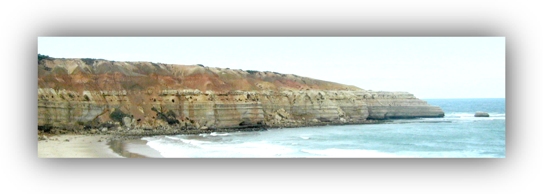

## Introduction

### Why the location is geologically significant

Maslin Bay and Port Willunga Bay together display a sequence of sedimentary rocks that were formed over a period spanning from 42 million years ago to the present day. Each of the rock types was formed under a unique set of conditions, ranging from a river estuary to a shallow sea.

Between 42 and 32 million years ago, the older rock layers were tilted to the south at about 5°, so it is possible to walk along the beach and study each layer as it slopes down to beach level.

While similar sequences of rocks can be seen at various locations along our southern beaches, the most complete and easily studied layers outcrop in the Cliffs at Maslin Bay and Port Willunga.

### Key Concepts to be covered before the excursion

These are linked to the Science Understanding strand of the Year 8 Earth and Space sciences statement in the Australian Curriculum.

* Processes that form sedimentary rocks.
* Timescales involved in the formation of the Maslin Bay/Port Willunga sequence.
* Observed physical and chemical properties of some common rock types
* The role of forces and energy in the formation of sedimentary rocks
* Recognising that some rocks provide valuable resources.

The geological history of the area to be visited should be discussed before the excursion. This is covered in pp 4 to 6 of this document. It will not be included in the student worksheet.

## Planning the Excursion

Allow at least half a day to complete this excursion.

**Check the tide tables. Do not select a date on which high tide occurs during the excursion.**

Visit the site, with the **Teacher Information Sheet** and the **Answers to Student Worksheet** documents prior to the excursion. Be prepared to discuss with the students the features described in the worksheet, and any other features of geological interest seen on the excursion

The southern end of Maslin Bay is reserved for both clad and unclad bathing.

There are toilets halfway down the path from Maslin Bay car park. The next toilets are at the end of the excursion route, in Port Willunga car park.

Print the worksheets single-sided and staple them with two staples down the side to make a booklet. This gives students extra space next to each page to include any information or diagrams that they cannot fit into the spaces provided with the questions.

Emphasise the importance of the **Rules for Students**,which areincluded in the worksheets.

Hand the worksheets out in the classroom when you are discussing the excursion with them and emphasise their importance. Collect them at the end of the lesson and hand them out again at the beginning of the excursion.

## Safety and Ethical Considerations

Carry a small first aid kit with you on the excursion.

If the students use geological hammers to collect fossils, they must wear safety goggles.

Make sure the students do not leave any litter.

Keep the students away from overhanging rocks and do not allow them to climb the cliffs.

Everyone must keep to the defined walking trails, except on the beach.

## Rules for Students (also included in the student worksheet)

Wear a hat, sturdy shoes and apply sunscreen even during winter months.

Carry drinking water

Carry sufficient food. There is nowhere to buy food until you get to the end of the excursion.

Safety First! Keep to the defined walking trail except when on the beaches

Avoid overhanging rocks, which could potentially fall.

Stay well back from the tops of cliffs.

Weather conditions can change quickly. Ensure that you wear and bring appropriate clothing.

### Finding the Location

Figure 1 shows the route from Adelaide GPO to the starting point of the excursion. Allow about an hour for this journey.

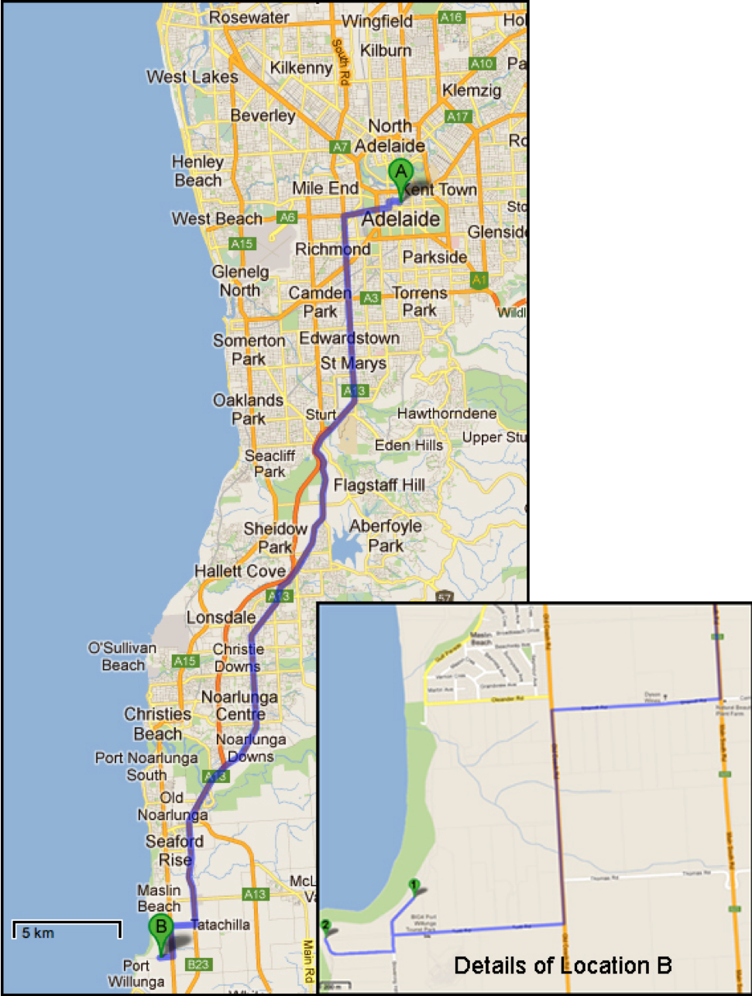

Figure 0 — How to Get There

# Geological History of the Area

## Geological time

This field guide refers to units of geological time using terms that might be unfamiliar to some people. A copy of the Geological Time Scale is included with these documents.

N.B. The abbreviation Ma means ‘millions of years’.

The Willunga Basin, with its layers of sedimentary rocks, is one of several similar basins on the eastern side of Gulf St. Vincent. The basins started to form when Australia and Antarctica began their rapid separation (continental drift). During Eocene time, 45–42Ma before the present, Australia accelerated its migration to the north (from < 2 to > 5 mm/year). Changes in the Earth’s stress field reactivated lines of weakness in the region of the ancient and eroded Mt Lofty Ranges. Movement along the fault lines formed the present Mt. Lofty Ranges as well as the basins

These faults and the Basins between them are shown in the Figure 2 below.

The Willunga Basin covers a relatively small area, which is bounded to the north by a high, up-faulted block of very much older rocks, and to the south by the high escarpment of the still active Willunga Fault.

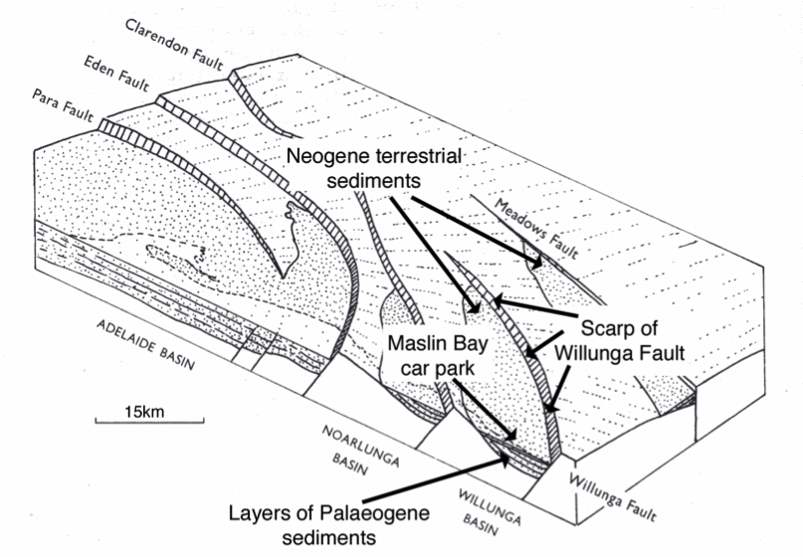

Figure 2 — Structure of the Willunga Basin

Once the basins were formed, they began to fill with sediments, and changing conditions have altered the nature of the sediments and the sedimentary rocks formed from them over the past 45Ma.

From about 30 000 to 18 000 years ago the Earth’s climate was intensely cold. Ice sheets covered much of North America and Europe, the Antarctic ice sheet was at its maximum thickness and extent, and glaciers formed in Tasmania and on the southern highlands of eastern Australia. With so much water frozen in place on the land, sea levels were 120–130m lower than they are today. With the onset of our present globally warmer climate, substantial amounts of glacial meltwater returned to the oceans, which reached present sea level about 7000 years ago. The coastal cliffs of Maslin and Port Willunga Bays are thus relatively new features formed by marine erosion. Today the west-facing outcrops are kept fresh by the back-cutting action of the sea and the washing effect of the winter storms.

All the rocks are sedimentary and they form a sequence of layers (strata). Their relative ages are easy to understand as you walk along the beach from north to south. Figure 3 shows the sequence of rock types we will be looking at. It indicates their relative ages and describes each rock type briefly. The wavy lines between some of the layers indicate periods when no sediments were being deposited and significant erosion was occurring. These periods are called **unconformities.**

Figure 3 — The Sequence of Rocks layers in the Willunga Basin

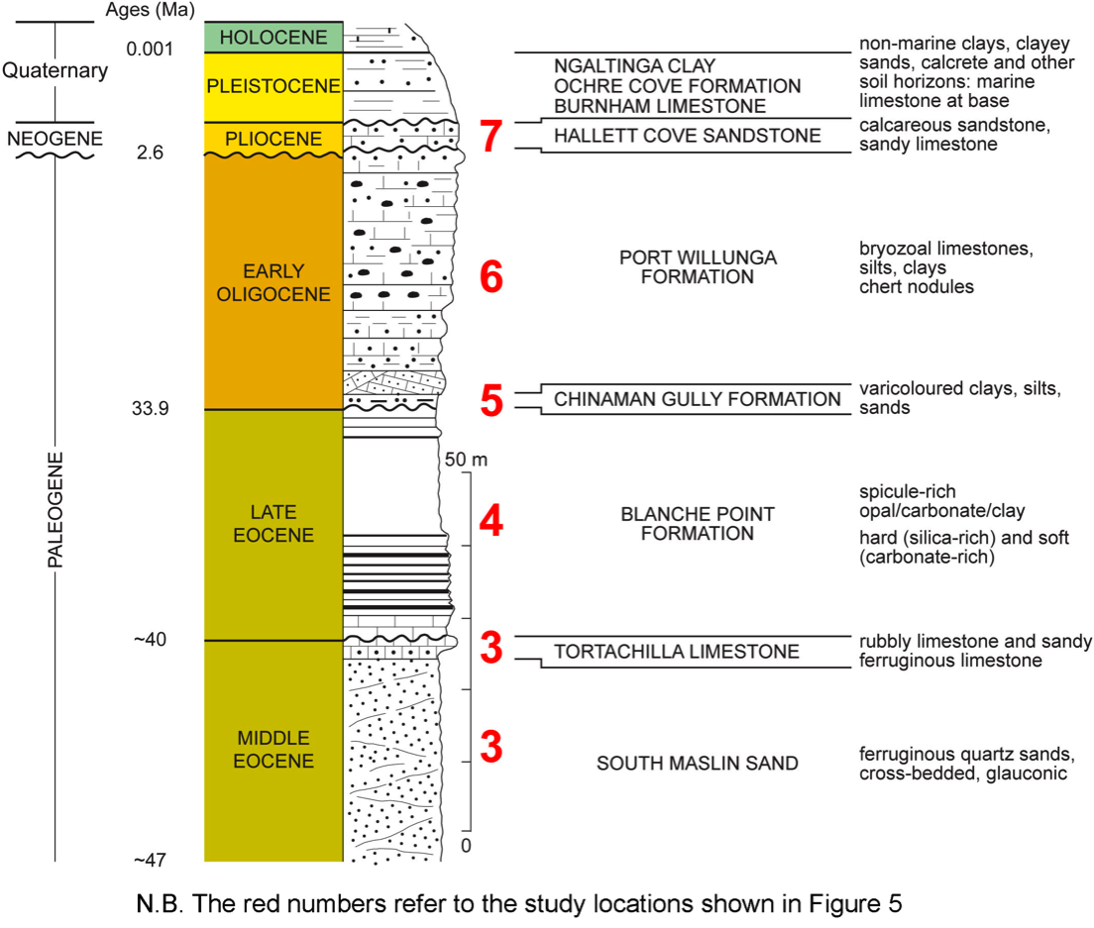

Looking south from Maslin Bay car park, you can see that the lower rock layers, which consist of Blanche Point Formation, dip gently towards Blanche Point and Gull Rock. However, about halfway up the cliff, a horizontal layer of strongly cemented sandstone — the Hallett Cove Sandstone — lies above these gently dipping layers. This upper layer represents a 20Ma break in deposition between the gently dipping and the horizontal layers. These dipping layers and the upper, horizontal layer are shown in Figure 4. The white, horizontal layer represents the most recent time that the area was under the sea. Sediments washed down from the Mt. Lofty Ranges have formed the layers above it. As shown figure 3, periods of erosion (unconformities) occurred both before and after the Hallett Cove Sandstone was deposited.

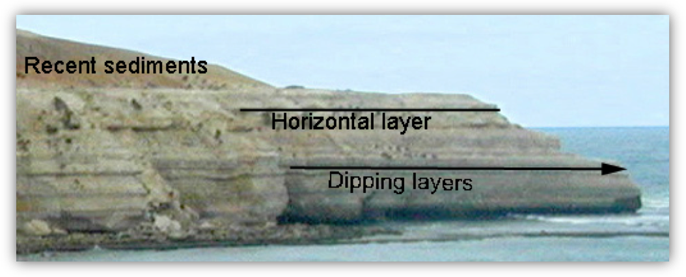

**Figure 4 — Horizontal and Dipping Layers**

# The Excursion

Figure 5 shows the excursion route. It involves parking in two different car parks, one above the southern end of Maslin Beach and the other at the northern end of Port Willunga Bay.

The features of geological interest discussed on p8 of the student worksheet may be found at different locations along the beach. Not all the features are always visible, as some may be covered by sand or under the sea, or they may have been eroded away.