## Stop I — Maslin Bay Car Park

Figure 5 — Route of Excursion and Study Locations

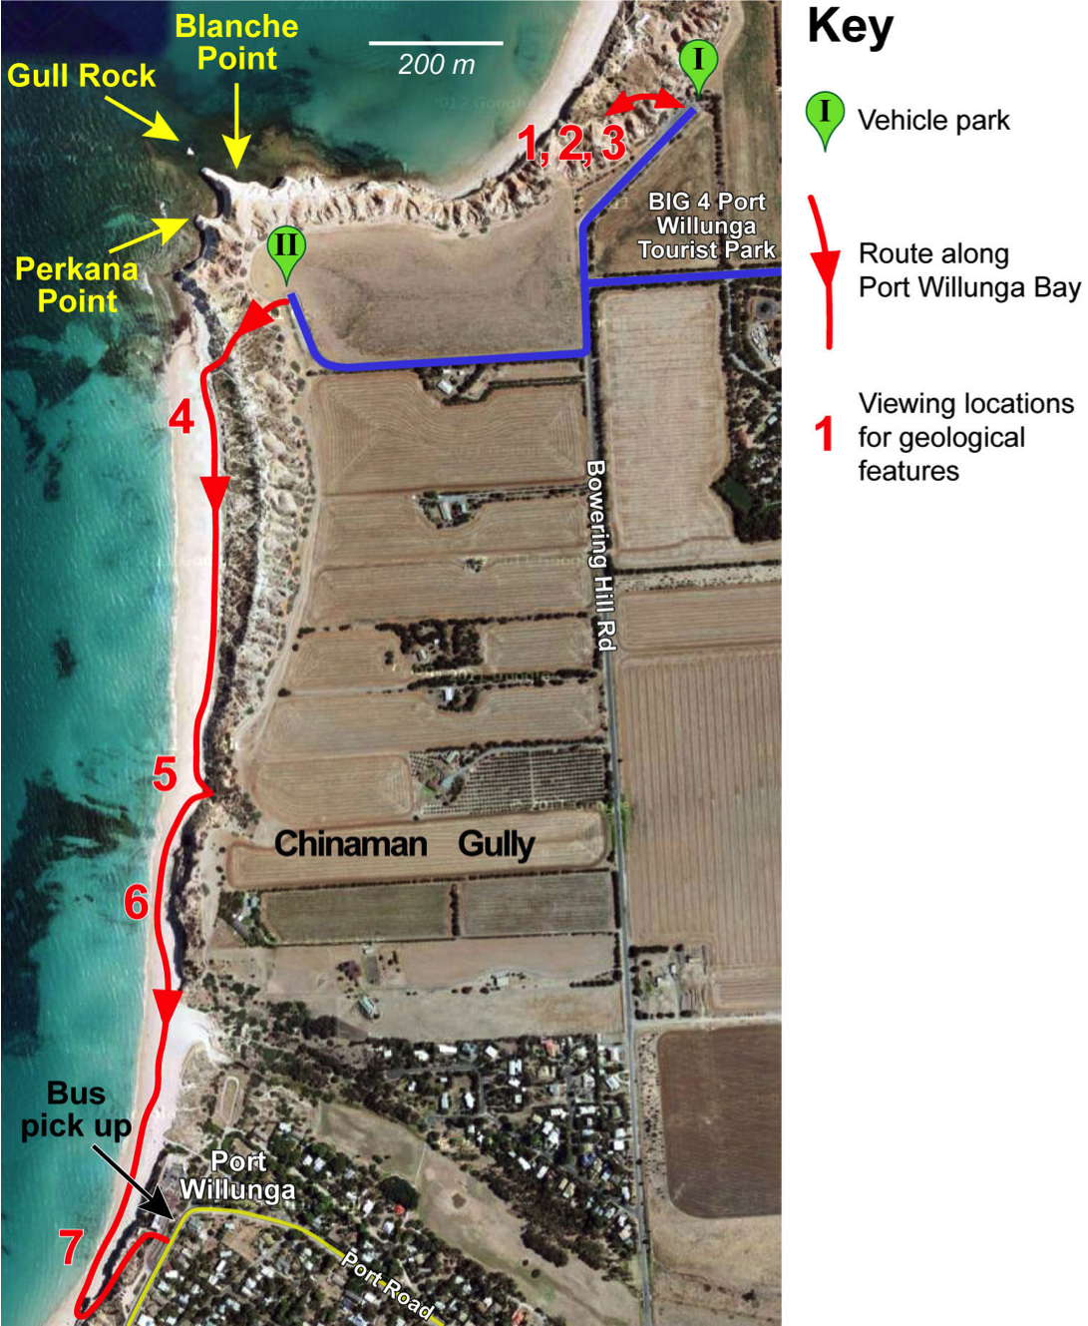

### Study locations 1,2 and 3 in figure 5

Stop in the Maslin Bay car park to study the following features, which are indicated:

1 Look inland to see the structure of the Willunga Basin and the fault scarp of the very old rocks that surround the basin. This is the Willunga Fault Scarp, which is illustrated in Figure 2.

2 Walk along the path to the beach, and look across the bay to see the dipping layers of Blanche Point Formation and the horizontal layers of Hallett Cove Formation, as shown in Figure 4.

3 Walk down the steps to the bend in the path to obtain a close-up view ofhe boundary between the oldest rock type visible in this area — South Maslin Sand — and the layer above it — Tortachilla Limestone. This boundary, which is shown in Figure 6, marks a change in the depositional environment from a poor to a rich marine environment.

Figure 6 — Boundary between two rock layers at a Bend in the Path

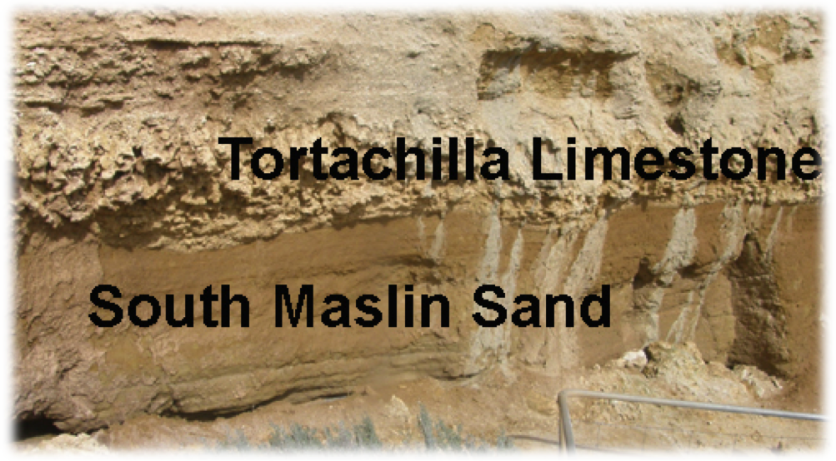

## Stop II — Car Park above Blanche and Perkana Points

To see the remaining rock types and geological features, walk down the cliff path and along the beach. Your walk along the beach will take you to study locations 4 to 7 in figure 5. If you have a bus, ask the driver to wait for you in the Port Willunga car park. Its location is shown in Figure 5.

As you walk along the beach, look for the distinctively coloured Chinaman Gully Beds. You will see them slope down towards beach level in Chinaman Gully itself.

### Study Location 4 — Blanche Point Formation.

The Blanche Point Formation, part of which is shown in figure 7, contrasts strongly with the Tortachilla Limestone, even though it too is rich in fossils. Fossils of turreted snails especially are extremely abundant in some layers, intensive burrows in others, sponge gardens in yet others. The unweathered sediments are dark grey (not white as suggested by the word ‘Blanche’) and rich in finely disseminated opal, derived from sponges and diatoms. This points to abundant runoff forming a brackish, low-density surface layer on the sea, inhibiting circulation and gas exchange with the atmosphere.

Figure 7 shows that the formation is not uniform all the way up the cliff. It has been divided into three members, of which the lower two are shown in the photograph. The Gull Rock Member is hard and banded, while the Perkana Point Member is softer and more uniform. These differences indicate that there must have been comparatively minor changes in the conditions of sedimentation over the millions of years during which the Blanche Point Formation sediments were deposited.

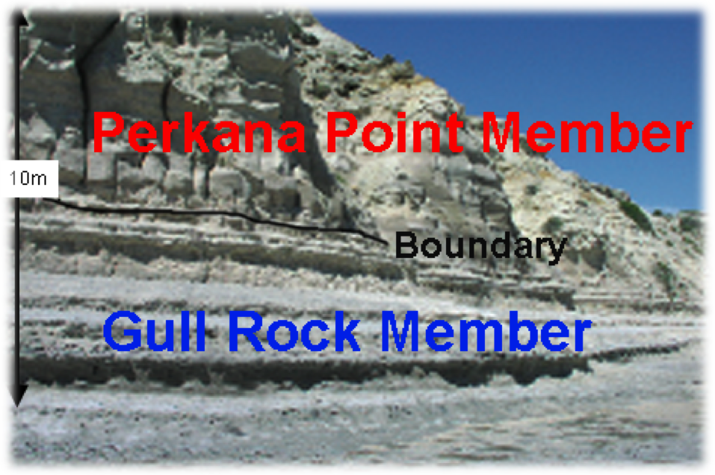

Figure 7— The two Lower Members of the Blanche Point Formation

### Study Location 5 — Chinaman Gully Formation

This formation almost reaches ground level in Chinaman Gully. Walk into the gully to see its clays, with bright weathering greens, reds and browns.

Figure 8 shows this small formation (B) sandwiched between the Blanche Point Formation (C) and the Port Willunga formation (A).

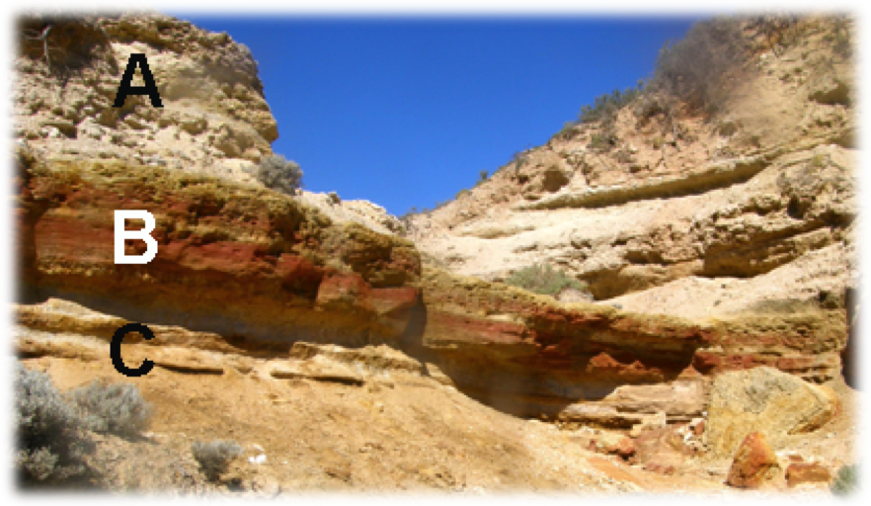

Figure 8 — Chinaman Gully Formation

Deposition of the Blanche Point Formation ceased exactly at the time when (on global evidence) the ice sheet on Antarctica first grew to seriously large dimensions and global sea level was lowered accordingly. At Port Willunga the Chinaman Gully Formation was formed during this deposition of non-marine sediments.

### Study Location 6 — Port Willunga Formation

The two parts of Figure 9 show the hard sandstone of the Port Willunga Formation jutting out above the Chinaman Gully Formation. Comparison of the two photographs emphasises the differences between the strengths of the two rock types.

Figure 9 — Two Views of the Boundary between the Port Willunga

and Chinaman Gully Formations

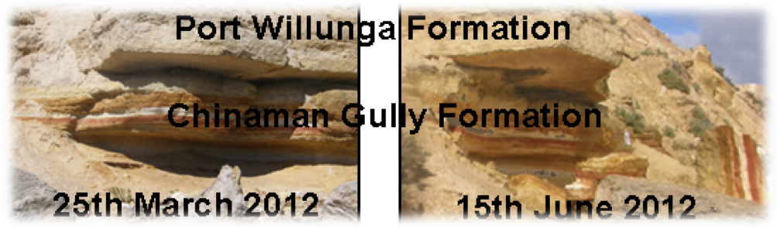

Following deposition of the Chinaman Gully Formation, the sea returned to produce a succession of marine environments — shore sands, deeper water sands and muds, which developed into the Port Willunga Formation. The bryozoan- and echinoid-rich fossil assemblages that are preserved in these sediments of the new Southern Ocean are much more like modern shallow-water marine faunas than those of the Blanche Point Formation.

### Study Location 7 — Faults in the Cliffs, Evidence of Human Activity, Hallett Cove Sandstone and the more Recent Sediments.

Do not walk up the first exit point from the beach, but continue to the remains of the old jetty. The cliff face around this point contains many features of interest.

The Port Willunga Formation is faulted in several places. The protruding formation in figure 10 appears to have has moved down compared with the main part of the cliff. This type of fault is a normal fault, since the hanging wall has moved down compared with the foot wall. See Appendix 1 for more details about normal and reverse faults.

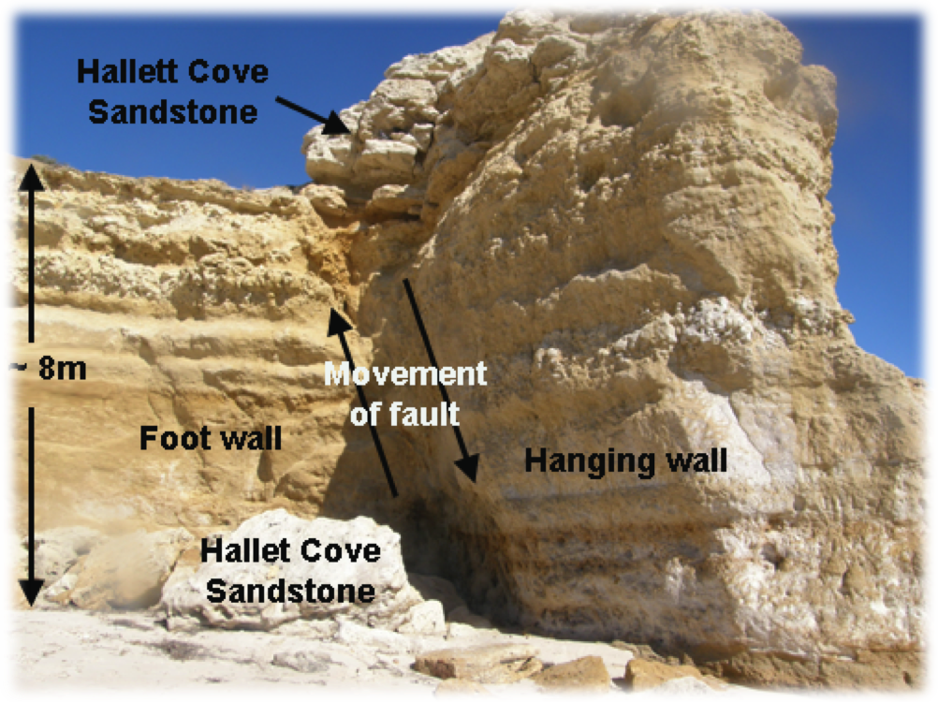

Figure 10 — One of the Faults in the Cliffs

The large white slabs on the beach consist of the rock layer above the Port Willunga Formation — the fossiliferous Hallett Cove Sandstone. It has fallen from a higher level on the cliff. Since it is harder than the Port Willunga Formation, the blocks on the beach have not been eroded away so easily.

There is also evidence of past human activity at this location. There are several artificial caves, which have been used for several purposes. One function of the caves was to store slate from the Willunga quarries before loading it onto boats for transfer to Adelaide.

It may be possible to see the remains of the old cobbled road, which was used to bring the slate, and any other cargo, down to the beach. The modern road up the cliff is further inland than the old road, providing evidence that the sea is encroaching onto the land in this area.

As you walk up the road to the bus, you will pass the Hallett Cove Sandstone and the more recent sediments. The table in the student worksheet can therefore be completed here.

### References:

Talbot, J.L. and Nesbitt, R.W. Geological excursions in the Mount Lofty Ranges and the Fleurieu Peninsula. Angus and Robertson, Sydney 1968.

The Field Geology Club of SA Inc. A Field Guide to the Coastal Geology of the Fleurieu Peninsula Gillingham Printers, Adelaide, South Australia 1986

Pamphlet — Government of South Australia, Primary Industry and Resources, SA Maslin Bay and Port Willunga Geological Trail, 2011. Original text prepared by B. McGowran and Geological Society of Australia (SA Division) Field Guide Subcommittee.

# Appendix 1 — Normal and Reverse Faults

## Joints and Faults

Joints and faults are formed at or near the earth's surface when sudden forces, such as earthquakes, act on rocks.

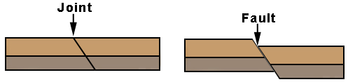Joints are fractures in rocks along which no appreciable movement has occurred. Rocks on either side of a **fault** have moved, whereas rocks on either side of a **joint** have remained stationary.

## Terms used when describing faults

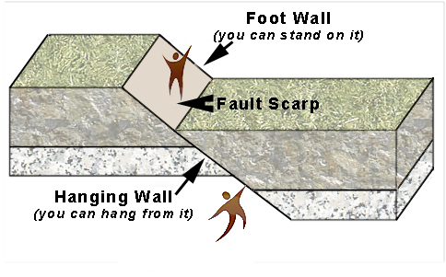

## Normal Faults

The diagram below shows **a normal fault.**

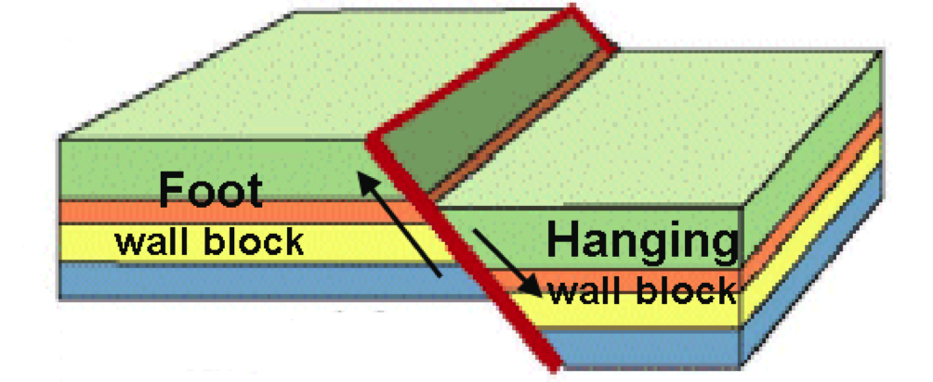

**Extension** forces produced this fault.

The **hanging wall** block has moved **down** compared with the **foot wall** block

## Reverse Faults

The diagram below shows the essential features of a **reverse fault**

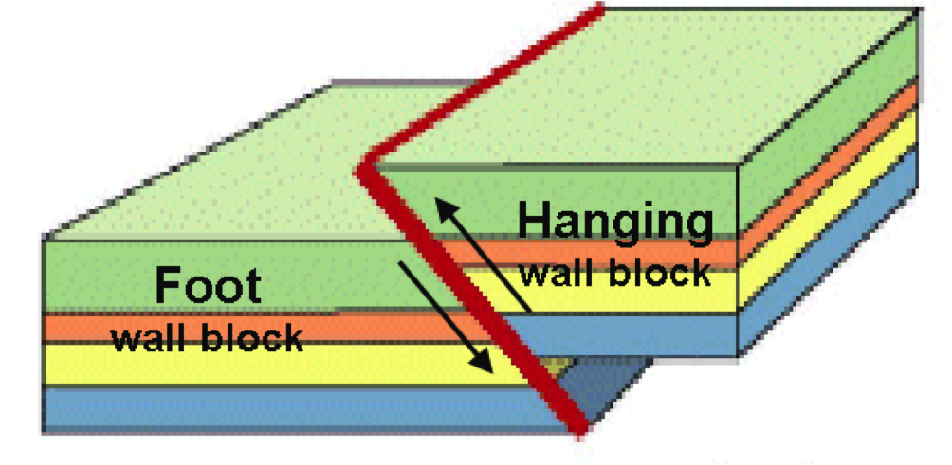

**Compression** forces produced this fault.

The **hanging wall** block has moved **up** compared with the **foot wall** block**.**